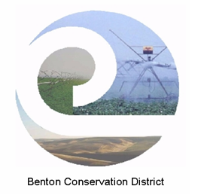

Water Quality Monitoring - Final Report

Lower Yakima River Water Quality, Nutrient, and Aquatic Vegetation Dynamics Study

Agreement Number (s): WQC-2018-BentCD-00065

EIM Study ID Number: WQC-2018-00065

Report Begin / End Date: June 01, 2018 to September 1, 2020

Study Begin / End Date: June 01, 2018 to December 30, 2021

Final Report – January 2022 (draft)

Publication Information

Data for this project are stored in the [U.S. Geological Survey (USGS) National Water Information System (NWIS) database](https://waterdata.usgs.gov/nwis)[1], USGS Site IDs: 12511800; 12509489; 12510500.

**Suggested Citation:**

Appel, M., R. Sheibley, and J. Foreman. 2020. Water Quality Monitoring – Final Report, Lower Yakima River Water Quality, Nutrient and Aquatic Vegetation Dynamics Study. Benton Conservation District, Kennewick, WA.

Contact Information

Marcella Appel, Author and Principal Investigator

Benton Conservation District

10121 W. Clearwater Ave Ste. 101

Kennewick, WA 99336

(509) 736-6000

Rich Sheibley, Principal Investigator

U.S. Geological Survey

934 Broadway, Ste. 300

Tacoma, WA 98402

(253) 552-1611

Heather Simmons, Project Manager, Water Quality

Washington Dept. of Ecology, Water Quality Program, Central Region

1250 W. Alder St., Union Gap, WA 98903-0009

(509) 454-7207

Washington State Department of Ecology – <https://ecology.wa.gov>

* Headquarters, Olympia 360-407-6000
* Northwest Regional Office, Bellevue 425-649-7000
* Southwest Regional Office, Olympia 360-407-6300
* Central Regional Office, Union Gap 509-575-2490
* Eastern Regional Office, Spokane 509-329-3400

Cover photo: Yakima River at Prosser, WA. Stephen Ingalls, Benton Mosquito Control.

Any use of product or firm names in this publication is for descriptive purposes only and   
does not imply endorsement by the author or the Department of Ecology.

To request ADA accommodation for disabilities, or printed materials in a format for the visually impaired, call Ecology at 509-575-2490 or visit our [accessibility website](https://ecology.wa.gov/About-us/Accessibility-equity/Accessibility)[2]. People with impaired hearing may call Washington Relay Service at 711. People with speech disability may call 877-833-6341.

**Water Quality Monitoring - Annual Report**

Lower Yakima River Water Quality, Nutrient, and Aquatic Vegetation Dynamics Study

by

Marcella Appel

Benton Conservation District

Kennewick, Washington

Rich Sheibley

U.S. Geological Survey

Tacoma, Washington

*This page is purposely left blank.*

# Table of Contents

Table of Contents v

1.0 Executive Summary 1

2.0 Acknowledgements 2

3.0 Introduction 3

3.1 Introduction and problem statement 3

3.1.1 Background 3

3.1.2 Goals and objectives 4

3.2 Study area and surroundings 5

3.2.1 History of the study area 7

3.2.2 Summary of previous studies and existing data 8

3.2.3 Parameters of interest and potential sources 10

3.2.4 Regulatory criteria or standards 10

4.0 Methods 13

4.1 Continuous and discrete sample data collection 13

4.1.1 Sampling locations 13

4.2 Sampling and measurement procedures 15

4.2.1 Water quality sampling 15

4.2.3 Discrete nutrient analysis QC sample collection 16

4.2.3 Aquatic biomass collection 16

4.3 Data management 17

4.3.1 Continuous water quality data 17

4.3.2 Discrete sample data 18

4.3.3 Aquatic biomass data 18

5.0 Data Quality Control and Assesment 19

5.1 Quality control procedures and data verification 20

5.1.1 Continuous sample data 20

5.1.2 Discrete nutrient sample data 23

5.1.3 Aquatic biomass quality control assesment 26

5.2 Field conditions 26

6.0 Results and Analysis 28

6.1 Water quality dynamics 28

6.1.1 Flow 28

6.1.2 Water temperature 32

6.1.3 Dissolved oxygen 34

6.1.4 pH 36

6.1.5 Turbidity 38

6.1.6 Nitrates, nitrites, and orthophosphates 41

6.2 Water stargrass dynamics 43

6.2.1 Biomass growth between years 44

6.2.2 Biomass relationships 49

6.3 Data issues 51

6.4 Data changes 52

7.0 Conclusions 53

8.0 Recommendations 55

9.0 References 58

Appendix A. Discrete Sample Dates 62

List of Figures

Figure 1. Map of Lower Yakima Study Reach in Benton County, WA. 6

Figure 2. USGS Lower River Water Quality Monitoring locations. 14

Figure 3. Flow as measured at Kiona in feet for the project reporting period. Data from waterdata.usgs.gov. 29

Figure 4. Gage Height at Kiona in feet for the project reporting period. Data from waterdata.usgs.gov. 30

Figure 5. Ambient Air Temperature (Benton City, E) near Kiona gage. Data are from the WSU AgWeatherNet monitoring database (weather.wsu.edu). 31

Figure 6. Daily maximum temperature at Prosser, Kiona, and Van Giesen monitoring stations. 33

Figure 7. Differences in Maximum Temperatures between Kiona and Prosser and Kiona and Van Giesen showing downstream warming trends. 34

Figure 8. Daily dissolved oxygen minimum at Prosser, Kiona, and Van Giesen. 35

Figure 9. Daily dissolved oxygen range at Prosser, Kiona and Van Giesen. 36

Figure 10. Daily minimum pH values for all stations compared to the minimum criteria of 6.5. 37

Figure 11. Daily maximum pH values for all stations compared to the maximum criteria of 8.5. 37

Figure 12. Daily range in pH across the three monitoring locations from June 2018 to October 2020. 38

Figure 13. Maximum daily turbidity at Prosser from June 2018 to October 2020. The red line indicated the background value plus 5 FNU (FNU = 10). 40

Figure 14. Maximum daily turbidity at Kiona from June 2018 to October 2020. The red line indicated the background value plus 5 FNU (FNU = 18). 40

Figure 15. Maximum daily turbidity at Van Giesen from June 2018 to October 2020. The red line indicated the background value plus 5 FNU (FNU = 6). 41

Figure 16. Continuous Nitrate+Nitrite at Kiona and Van Giesen compared to discharge as measured at Kiona (Benton City,WA). 42

Figure 17. Continuous dissolved oxygen, pH, and nitrate from August 1st through 7th 2018 as measured at Kiona (Benton City, WA). 43

Figure 18. Box Plots of Water stargrass Biomass at Prosser. Box plot order from left to right: August 2018, June 2019, August 2019, September 2019, June 2020, August 2020. Boxes with the same lower case letters are considered to not have a statistically significant difference from each other. 47

Figure 19. Box Plots of Water stargrass Biomass at Kiona. Box plot order from left to right: August 2018, June 2019, August 2019, September 2019, June 2020, August 2020. Boxes with the same lower case letters are considered to not have a statistically significant difference from each other. 48

Figure 20. Box plots of water stargrass biomass at Van Giesen. Box plot order from left to right: August 2018, June 2019, August 2019, September 2019, June 2020, August 2020. Boxes with the same lower case letters are considered to not have a statistically significant difference from each other. 49

List of Tables

Table 1. Water quality criteria for the study area. 11

Table 2. USGS Project Study locations. 14

Table 3. Parameters collected at Prosser, Kiona, and Van Giesen (Figure 2). 15

Table 4. Number of Discrete field sample checks at Prosser, Kiona, and Van Giesen for Quality Control. 16

Table 5. Biomass Sampling Dates. 17

Table 6. Measurement quality objectives for field meter measurements. 19

Table 7. Measurement quality objectives for laboratory analyses of water samples. 20

Table 8. MQOs for continuous monitoring checks at Prosser, Kiona, and Van Giesen. 22

Table 9. Results from laboratory instrument blanks from June 1, 2018 to Sept 30, 2020. MQOs are provided in Table 7. 23

Table 10. from laboratory continuous calibration verifications from June 1, 2018 to Sept 30, 2020. MQOs are provided in Table 7. 24

Table 11. Results from laboratory third party checks from June 1, 2018 to Sept 30, 2020. MQOs are provided in Table 7. 24

Table 12. Results of field replicates from June 2018 to October 2020. 25

Table 13. Summary of data gaps in continuous water quality records for all stations from June 2018 to October 2020. 27

Table 14. Summary of the number of days of 1-Day Max Exceedances by year across all stations. WY 2018 was a shorter season with the first year of sonde deployment. 33

Table 15**.** Number of days when dissolved oxygen was less than 8.0 mg/L. 35

Table 16. Summary of discrete nutrient data collected at the monitoring locations from June 2018 to October 2020. 41

Table 17. Results for water stargrass biomass from August 2018. 43

Table 18. Results for water stargrass biomass from August 2018. 44

Table 19. Average water stargrass biomass from June through September 2019. 44

Table 20. Average water stargrass biomass from June through August 2020. 45

Table 21. Discrete field sample checks at Prosser Quality Control analysis. 62

Table 22. Discrete field sample checks at Kiona Quality Control analysis. 63

Table 23. Discrete field sample checks at Van Giesen for Quality Control analysis. 64

# 1.0 Executive Summary

Benton Conservation District and the U.S. Geological Survey (USGS) collaborated on a water quality, nutrient, and aquatic vegetation study with funding provided by the Washington State Department of Ecology (Ecology) through the Centennial Clean Water Grant Program (WQC-2018-BentCD-00065). The primary goal of this study is to collect quality data that will aid stakeholders in identifying and prioritizing actions to improve water quality, mitigating excessive macrophyte growth, and restoring functional conditions in the lower Yakima River.

USGS staff installed three continuous water quality-monitoring stations at Prosser, Benton City (Kiona), and West Richland (Van Giesen) to operate from June 2018 through September 30, 2020. USGS staff successfully monitored all three locations for temperature, pH, dissolved oxygen (DO), turbidity, and specific conductance for the project period. USGS staff collected continuous data every 15 minutes and telemetered the data in real-time to the USGS National Water Information System (NWIS) database. In addition, they collected continuous nutrient data in-situ at Kiona and Van Giesen. This is the first time continuous nutrient data has been collected for the lower Yakima. USGS staff collected measurements of water stargrass (*Heterantera dubia*) biomass and percent cover estimates multiple times during the growing season at all three monitoring locations in the summer of 2019 and 2020.

The study results show that water stargrass does influence water quality (particularly DO and pH), but the results are variable based on the time of year, site specific river conditions (hydrology), and the quantity of plant biomass. The study results indicate that during late spring and summer, the DO and pH levels greatly fluctuate in the lower Yakima and are in violation of Washington State’s water quality criteria. The daily change in DO and pH was variable between sites and depends on both biomass and site hydrology. A downstream warming trend was observed from Prosser to West Richland; all three sites exceeded the 21°C temperature threshold at baseflow conditions. The violations of pH, DO, and temperature likely impact late spring and summer migration of the lower Yakima salmon populations. Migratory fish populations will encounter inhospitable temperature conditions during the day during baseflow conditions. At night when temperatures moderately cool, they are more likely to encounter lower levels of dissolved oxygen. This leads to a challenging situation where fish must balance thermal and respiratory needs while migrating through the lower Yakima.

Continuous in-stream nitrate plus nitrite values were lower than anticipated for a predominantly agricultural river system. Nutrients within the water column showed evidence it was being used by the plant community to some extent. However, further studies investigating nutrient cycling between biomass and the sediment/water column are warranted to determine if water stargrass is a nutrient sink within the lower Yakima River.

# 2.0 Acknowledgements

The authors of this report thank the following people for their contributions to this work:

US Geological Survey

* James Forman, Certified Hydrologic Technician
* Julia David, Ecologist
* US Geological Survey Staff at the Kennewick Field Office

Benton Conservation District

* Rachel Little, Education and Outreach Specialist

Washinton State University – Tri-Cities

* Aaron Pelly, PhD Student

Washington Department of Ecology

* Heather Simmons
* Jenifer Parsons
* Dan Wise
* Environmental Assessment Program Reviewers

3.0 Introduction

## 3.1 Introduction and problem statement

### 3.1.1 Background

Many parts of the lower 50 river miles of the Yakima River, below Prosser Dam (lower Yakima), are frequently dominated during the summer by a rooted aquatic macrophyte called *Heterantera dubia*, or water stargrass. Water stargrass thrives in the lower Yakima in a variety of habitats, ranging from finely silted slack water to higher velocity cobble substrates. Despite its classification as a native aquatic plant, water stargrass in the lower Yakima acts like an invasive species, exploiting river conditions. Water stargrass can form bank-to-bank monocultures with magnified effects in low water years. Local scientists have observed moderate water stargrass densities from Prosser to Benton City in areas where faster riffles and large rocky substrates dominate.

Water stargrass causes a multitude of problems for the beneficial uses within the lower Yakima. The abundance of water stargrass physically displaces the river and influences sedimentation and river temperatures. Fall Chinook spawning, once prevalent in the lower Yakima, has shifted above Prosser Dam as a result of decreased spawning gravel quality. Wise et al. (2009) reported that water stargrass greatly influenced river pH and dissolved oxygen (DO) levels during the irrigation season causing degraded water quality conditions. McMichael (2017) noted that high summer river temperatures, lower DO levels, increased pH levels, and dense water stargrass strands might provide favorable conditions for the recruitment and refuge of non-native predator species to the detriment of native salmon species.

Dense water stargrass stands also degrade side-channel habitat, block irrigation ladders at the lower river dams, impact irrigation function, and impede recreational benefits of the lower Yakima. More recently we have learned that water stargrass impacts local public health. Flowing river water is slowed in areas of dense water stargrass growth resulting in ponded areas that provide breeding grounds for disease carrying mosquitos.

In response to problematic water stargrass growth, South Yakima Conservation District (SYCD) and the United States Geological Survey (USGS) monitored the river and its aquatic plants, resulting in the publication of the *Assessment of Eutrophication in the Lower Yakima River Basin, Washington, 2004-07*; subsequently referred to as the ‘Eutrophication Study’ (Wise et al. 2009). USGS and SYCD designed this study as a first step in understanding large-scale relationships between water quality (temperature, pH, DO, conductivity, and turbidity), nutrients, and abundant aquatic plant growth. The Eutrophication Study surmised that light availability as influenced by turbidity, phytoplankton abundance, and water depth, was more likely to limit macrophyte growth than nutrient availability. Wise et al. (2009) mention that the development of management actions to mitigate water stargrass would require further detailed research into the complex relationships between aquatic plant growth, nutrients, DO, and pH, and by utilizing continuous monitoring on a more refined reach-scale. The authors also noted that, “*Data from [additional] monitoring could help in model development and in assessing the effectiveness of future water quality management actions”* (pg. 58, Wise et al. 2009).

Benton Conservation District (BCD), in cooperation with USGS, initiated a more comprehensive and detailed water-quality monitoring effort on the lower Yakima to increase our understanding of the complex relationships and drivers between water quality and growth of water stargrass at a more micro-scale than conducted by the Eutrophication Study. We developed this project with multiple local, county, state, tribal, and federal agencies in response to the severe aquatic vegetation growth that has impaired function in the lower Yakima, especially in drought years. The Yakima River Basin is considered one of the most vulnerable watersheds in Washington State for climate change impacts, with summers predicted to become warmer and dryer (Pickett 2016). As water demands in the basin increase, it is imperative that the question of how to improve lower Yakima water quality, support thermal refuge locations, and mitigate water stargrass growth are addressed. This detailed studied supported ongoing multi-agency efforts geared towards overall Yakima River water quality improvement, water supply management, and improved salmonid survival.

This report details the water quality and plant biomass collection results and the adherence to quality assurance/quality control procedures. We will discuss the results in relationship to current water quality criteria on the lower Yakima River. Two corresponding reports from this project are the *Water stargrass Recommendations* Report (Appel et al. 2022) as well as the *USGS Scientific Investigations Report* (Sheibley et al. 2022) and should be consulted for additional project details and research highlights.

### 3.1.2 Goals and objectives

The end goal of this study is to help develop priorities and management actions for targeted improvements in lower Yakima for habitat and water quality based on a scientific understanding of the interplay between biomass growth, hydrology, and water quality. We accomplished this goal by collecting up to date water quality data and biomass data on the lower Yakima over a period of two years at three locations of variable hydrology.

Specifically, we installed three continuous monitoring stations in the lower Yakima from May 2018 through September 2020 at Prosser (below the dam), Benton City (Kiona), and West Richland (Van Giesen). These stations monitored temperature, pH, DO, specific conductance, and turbidity. Additionally, we installed two continuous nitrate monitors at Benton City (Kiona) and West Richland (Van Giesen), providing the most comprehensive nitrate data to date, for the lower Yakima. Level data and flow are independently collected by USGS at the three monitoring locations outside of this project funding. We are using these data to help interpret the results between water years.

To determine the relationships between water quality and plant growth, USGS staff collected measurements of water stargrass biomass and percent cover estimates multiple times during two growing seasons (2019 and 2020) at multiple transects repeated near each monitoring station. We are analyzing the monitoring data to provide a calculation of whole stream metabolism and develop an annual load of suspended sediments (previously unavailable for the lower Yakima).

This project telemetered, in real-time, the most current, continuous, and detailed water quality information for the Kiona Reach. These data had value for multiple lower river projects, and as such has been continued under funding by the Yakima Basin Integrated Plan.

We have made the data and results of this project public to local stakeholders through yearly technical meetings, and to the community through targeted outreach meetings. Additionally, we formed a water stargrass technical advisory group (TAG) to help develop and prioritize actions that may improve water quality, mitigate water stargrass growth, and/or improve lower Yakima River salmonid habitat conditions and river function. Their recommendations along with the results of the research will support developed recommendations provided in the *Water stargrass Recommendations Report* (Appel et al. 2022) and outlined at the end of this report.

This Final Water Quality report provides a review and summary of the sampling protocols, data quality and usability, and data results as pertaining to water quality of the lower Yakima. The full analysis of the relationships between water quality, nutrients, metabolism and biomass dynamics will be further detailed in the corresponding *USGS Scientific Investigations Report* (Sheibley et al. 2022)*.*

## 3.2 Study area and surroundings

The lower Yakima River, located in south-central Washington State, flows through arid Benton County (Figure 1). Agriculture is the primary dominate land use in Benton County, supported by irrigation from the Yakima River. Columbia River basalts dominate between Prosser and Benton City, confining the river channel throughout this reach with minimal area for braiding and meander. Alluvial deposits are present between Horn Rapids and West Richland. Alluvial islands formed by Quaternary floods are dispersed throughout this reach and mediate changes in channel morphology.

Previous USGS geology studies indicate the lower Yakima to be a gaining reach, from Prosser to below the Chandler Power House. Above Benton City, the river transitions from a gaining reach to a predominantly losing reach. Possible sources of nutrients to the lower river include several overland irrigation return flows, and irrigation wasteways on the lower Yakima. Irrigation fed subsurface groundwater also contributes cooler water and either returns through subsurface pathways in the floodplain or irrigation wasteways to the Yakima. There are few floodplains and island side-channels on the lower river. The minimal floodplains that exist on the lower river are within Benton City, West Richland and Richland, Washington.

The lower Yakima passes through the towns of Prosser and Benton City, and forms the dividing line between Richland and West Richland in the Tri-cities before joining the Columbia River in Richland. The county’s irrigation use for agriculture and growing urban/residential development heavily influence Yakima River water quality and seasonal flow. The Yakima River is a highly managed system with regulated yearly flow regimes. The spring freshet typically occurs between April and May, with low flows and high temperatures occurring June through August. River temperatures rapidly cool with the onset of fall sometime between late August and early September. The irrigation season, which draws water from the Yakima River, runs from mid-March to mid-October.

The lower Yakima hosts anadromous runs of Steelhead Trout; spring, summer, and fall Chinook Salmon; Coho Salmon; and Sockeye Salmon. Juvenile salmon out-migrate through the lower Yakima to the Columbia River, and adult fish migrate from the Columbia up into the lower Yakima. Historically, the lower Yakima hosted fall Chinook spawning habitat. Abundant water stargrass growth in the lower Yakima has resulted in a shift of fall Chinook spawning to above Prosser Dam. As a result, adult and juveniles must migrate further, decreasing their chances of survival.

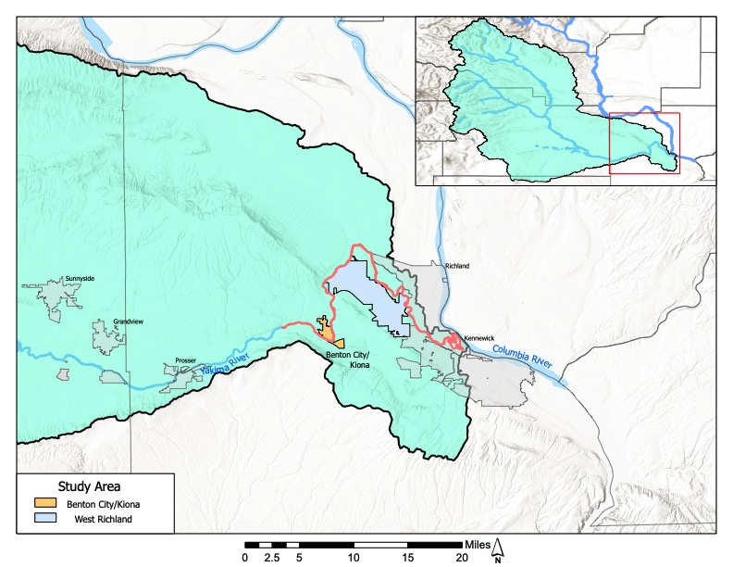

Figure 1. Map of Lower Yakima Study Reach in Benton County, WA.

### 3.2.1 History of the study area

Land use in the lower Yakima valley is predominantly irrigated agriculture that is heavily reliant on the Yakima River for irrigation water supply. For decades, high temperatures and suspended solids, turbidity, DDT, and other pesticides have been documented in the lower Yakima. By the mid-1990s, water quality evaluations by the USGS indicated that some improvements had been made, but beneficial uses were still impaired by sediment and sediment-borne pollutants, like DDT, from irrigation returns (Rinella et al. 1999). As a result, several reaches of the lower Yakima and several of its tributaries did not meet numerous state water quality criteria and federal guidelines. Consequently, Ecology placed these water bodies on Washington State's 303(d) list.

Water quality issues of concern in the entire Yakima River basin range from fecal coliform bacteria to suspended sediments and turbidity, as well as toxics, pH, nutrients, dissolved oxygen, and temperature. The water quality issues in the basin impact the beneficial uses of the water, potentially making it unsafe for drinking or recreation and threatening the health of aquatic animals and fish living in it.

At this time there are two fish species listed as Threatened under the federal Endangered Species Act: mid-Columbia bull trout and mid-Columbia steelhead. Conley and others (2009) summarized studies in the upper and middle Yakima River that indicated temperature, toxic chemicals, and lack of foraging habitat and refuge from predators were creating obstacles for survival of these species.

The primary water quality improvement projects conducted on the Yakima River are part of the Yakima River Watershed Toxic Reduction Program. These projects have been implemented to decrease the Total Maximum Daily Loads (TMDLs) of toxics, sediment and DDT. These projects are in various stages of development across the watershed. The primary TMDL projects in the lower Yakima include:

*Yakima River: Toxics Reduction Program*

Water quality monitoring of DDT, dieldrin, and other chlorinated pesticides (Johnson et al. 2010).

*Lower Yakima River: Suspended Sediment and DDT*

* TMDL evaluation report about the amount and sources of several pollutants the lower Yakima River (Joy and Patterson 1997).
* TMDL study evaluating controls of suspended sediment, which is the primary cause of turbidity and major source of DDT transport in the lower basin during irrigation season (Joy 2002).

The work related to these TMDL projects can be accessed through the Washington State Department of Ecology Website at:

Lower Yakima Watershed Pesticides Reduction Project: [Yakima Watershed Toxics Reduction Project](https://ecology.wa.gov/Water-Shorelines/Water-quality/Water-improvement/Total-Maximum-Daily-Load-process/Directory-of-improvement-projects/Yakima-watershed-toxics-reduction-project)[3]

Wise et al. (2009) theorized that the expansion of water stargrass over the last couple of decades was due to a combination of effects including the dramatic improvements made in water clarity as part of the shift in remediation efforts to decrease sediment loads to the Yakima River through changes in agricultural and irrigation practices.

### 3.2.2 Summary of previous studies and existing data

In 1997, Ecology published a TMDL evaluation report on the lower Yakima (Joy and Patterson 1997). The TMDL noted that the relationship between turbidity, suspended sediment, and DDT would likely change significantly after most of the suspended sediment was removed from the river. The U.S. Environmental Protection Agency (EPA) approved the TMDL for the protection of chronic aquatic life and turbidity criteria in 1998, but did not approve it for achieving compliance with the more restrictive human health pesticide criteria.

Carroll and Joy (2001) modeled the lower 47 miles of the Yakima River from below Prosser to Richland using QUAL2E. They used the model to evaluate potential water quality changes that might arise from proposed operational changes by the U.S. Bureau of Reclamation (USBR) at the Chandler Canal and Columbia Canal diversions. As part of the study, they conducted two synoptic sampling events in 1999 and 2000 in the lower river for multiple parameters including temperature, DO, TSS, conductivity, nutrients, pH, and Chlorophyll a.

In 2010, Ecology published the *Yakima River Pesticides and PBCs Total Maximum Daily Loads, Volume 1. Water Quality Study Findings* (Johnson et al. 2010). The study analyzed Section 303(d) listed pesticides, PCBs, suspended sediment, and turbidity in Yakima River surface waters, effluents, and stormwater. The study determined that despite reductions in soil erosion, elevated levels of suspended sediment inputs to the river remain. The study found the lower Yakima continues to have Category 5 listings for DDT, DDE, DDD, and dieldrin (Johnson et al. 2010).

The Eutrophication Study (Wise et al. 2009) monitored water quality parameters, nutrients, temperature, and flow during the irrigation season along the lowest 116 miles of the Yakima River, dividing the river into three reaches based on geomorphology, habitat, aquatic plant, and water quality conditions. The Kiona reach (Prosser to Richland) experienced abundant macrophyte and epiphytic algae growth, relatively high nutrient concentrations, and large daily fluctuations in DO and pH levels. The study noted that due to abundant macrophyte growth, pH, and DO levels exceeded state water quality standards in all years sampled. The study included monitoring in 2005, which was a drought year.

In 2011, BCD summarized two years of lower Yakima temperature monitoring and habitat assessments in the *Assessment of the Lower Yakima River in Benton County, Washington* (Appel et al. 2011). Expanding on work by Vaccaro (2001), BCD conducted thermal profiles of the Kiona Reach at baseflows in 2008 and 2009 to identify temperature heterogeneity within the lower river. Appel et al (2009) noted that river summer temperatures were well above 21°C for the 2008 and 2009 summertime floats; however, they identified thermal heterogeneity within the lower reach with “cooler” areas resulting from non-point source seeps, irrigation wasteways, and deeper “holes”. The “cooler” areas are located along the riparian area and in some instances behind side channels (island at I-182 bridge).

Pickett (2016) provided a summary of past studies and data relevant to multiple Yakima River reaches. Relevant past studies in his review have included modeling of Yakima River temperatures; modeling of DO and pH in the lower Yakima below Prosser; numerous studies of hydrogeology, groundwater, flood plain morphology, and thermal regimes; routine ambient monitoring; and an Ecology reconnaissance survey during the summer of 2015 in which pH, DO, and temperature were monitored in the lower river. The 2015 reconnaissance survey collected synoptic data samples in August and September during the most recent drought year.

In 2017, the Yakima Basin Fish and Wildlife Recovery Board commissioned a review of available literature on the lower Yakima River regarding water quality, macrophyte growth, predator fish populations, and native salmon survival data. McMichael reviewed the literature and published *Factors influencing Predation on Juvenile Fishes Emigrating through the Lower Yakima River Basin* (2017)*.* McMichael noted that the abundance and effectiveness of predator species appears to have increased over time, which may in part be due to changes in lower Yakima water quality and the associated expansion of water stargrass.

The Rosa Sunnyside Board of Joint Control have been collecting nutrient data at the major wasteways along the lower Yakima since 1996. They analyze the wasteways three times per month during irrigation season (March – October) and once per month the remainder of the year. They analyze samples for nitrite+nitrate, Total Kjeldahl Nitrogen (TKN), T-phosphate, ortho-phosphate, and ammonia. They collect samples at the outflow of the wasteways prior to entrance into the mainstem of the Yakima River. Data are available for Grainger Drain and Sulphur Creek wasteways located above Prosser and Spring and Snipes Creek wasteways located below Prosser.

BCD performed a comprehensive literature review and investigated water stargrass management techniques with funding through the Yakima Basin Fish and Wildlife Recovery Board. A techniques report was finalized in 2021 highlighting the top tier management techniques for controlling water stargrass in the lower Yakima River (Pelly and others 2021).

### 3.2.3 Parameters of interest and potential sources

Washington State’s list of impaired waterbodies under Section 303(d) of the Clean Water Act lists the lower Yakima as impaired for water temperature, DO, turbidity, pH, fecal coliform bacteria, and toxics.

The main parameters of interest we focused on for this study are temperature, pH, specific conductance at 25°C, DO, nitrates, and turbidity.

High extreme temperatures in the lower Yakima (over 21**°**C) exist during baseflow conditions primarily as a result of natural seasonal changes in solar heat flux. Warm water summer temperatures favor salmonid predators and create inhospitable conditions for anadromous species.

Suspended solids originating from Yakima Basin agricultural lands (historical and current) can carry pesticides, chemicals (PCBs), and nutrients (nitrogen and phosphorus) into the lower Yakima water body, and alter river turbidity. Suspended solids impair fish and aquatic insect respiration. Particles can also settle and clog spawning gravel or suffocate fish eggs.

DO capacity in the Yakima River is dictated by atmospheric pressure, water volume, and temperature. DO levels can fluctuate within a river system as a result of photosynthesis and respiration from aquatic plants and algae. The amount of variability in DO levels in the Yakima River largely depends on the amount of biomass respiration and photosynthesis.

The hydrograph of the lower Yakima is highly managed for agriculture and fish with timed releases from reservoirs and dams. From Prosser to Benton City is the bypass reach, named for the amount of water diverted at the Prosser Dam, utilized for agriculture and then re-released through the Chandler spillway. The alterations in flow may impact the biomass growth and dynamics at the three project study locations; Prosser, Benton City, and West Richland. Flow was only monitored at Kiona. The data are collected independent from this project under a separate funding source. The data undergo rigorous QA/QC by the local USGS Kennewick Field Office and is telmetered in real-tie to the NWIS-web.

### 3.2.4 Regulatory criteria or standards

*Water Quality Standards for Surface Waters of the State of Washington, Chapter 173-201A WAC* (Ecology 2019) established beneficial uses of waters and incorporated specific numeric and narrative criteria for parameters such as water temperature, DO, pH, and turbidity. The criteria define the level of protection necessary to support the beneficial uses. Washington Administrative Code (WAC) 173-201A-600 and WAC 173-201A 602 list the use designations for specific areas. The state has not yet established regulatory criteria for river nutrients.

For the lower Yakima, the designated uses of the waters include the following:

* Primary Contact Recreation.
* Water Supply Uses (Domestic Water, Industrial Water, Agricultural Water, Stock Water).
* Wildlife Habitat.
* Commerce/Navigation.
* Boating.
* Aesthetics.
* Aquatic Life.

Chapter 173-201A WAC defines the aquatic life for the lower Yakima as Salmonid Spawning, Rearing, and Migration. The key-identifying characteristic of this use is salmon or trout spawning and emergence that only occur outside of the summer season (September 16 - June 14). Other common characteristic aquatic life uses for waters in this category include rearing and migration by salmonids.

Table 1. Water quality criteria for the study area.

|  |  |  |  |  |  |
| --- | --- | --- | --- | --- | --- |
|  | Dates | Temperature | Dissolved Oxygen | pH | Turbidity |
| Yakima River from Cle Elum River to the mouth | Annual | 21**°**C 1-day maximum.  No human-caused increase of more than 0.3 oC if natural conditions exceed criteria. | 8.0 mg/L 1-day minimum.  No human-caused decrease of more than 0.2 mg/L if natural conditions exceed criteria. | 6.5 - 8.5  No human-caused variation of more than 0.5 units within this range. | • 5 NTUa over background when the background is 50 NTU or less; or  • A 10 percent increase in turbidity when the background turbidity is more than 50 NTU. |

aNTU: nephelometric turbidity units.

#### 3.2.4.1 Temperature criteria

Temperature levels fluctuate over the day and night in response to changes in climatic conditions and river flows. Since the health of aquatic species is tied predominantly to the pattern of maximum temperatures, most of Washington temperature criteria are expressed as the highest 7-day average of the daily maximum temperatures (7-DADMax) occurring in a waterbody.

However, WAC 173-201A-602 (Ecology 2019) provides the following special criteria for the Yakima River from mouth to Cle Elum River (river mile 186).

*Temperature shall not exceed a 1-DMax of 21.0°C due to human activities. When natural conditions exceed a 1-DMax of 21.0°C, no temperature increase will be allowed which will raise the receiving temperature by greater than 0.3°C; nor shall such temperatures, at any time, exceed t = 34/(T+9).*

The standards recognize, however, that not all waters are naturally capable of staying below the fully protective temperature criteria. When a waterbody is naturally warmer than the criteria described above, the standards provide an allowance for additional warming due to human activities. In this case, the combined effects of all human activities must also not cause more than a 0.3°C (0.54°F) increase above the naturally higher (warmer) temperature condition.

#### 3.2.4.2 Dissolved oxygen criteria

The DO criterion (Table 1) is a 1-day minimum and measured in milligrams per liter (mg/L) (Ecology 2019). Concentrations of DO are not to fall below the listed criteria at a probability frequency of more than once every ten years on average. The criterion allows that when a body of water is less than DO criterion or within 0.2 mg/L, then cumulative human actions may not cause the DO of that water body to decrease more than 0.2 mg/L.

#### 3.2.4.3 pH criteria

Lower Yakima pH levels for aquatic life uses must fall in the range of 6.5 to 8.5 with a human caused variation within this range of less than 0.5 pH units (Ecology 2019).

#### 3.2.4.4 Turbidity criteria

Turbidity, as measured in Nephelometric Turbidity Units (NTUs), is not to exceed 5 NTU over background when the background is 50 NTU or less, or show a 10 percent increase in turbidity when the background turbidity is more than 50 NTU (Ecology 2019).

# 4.0 Methods

The Project QAPP (Appel and Sheibley 2018) outlines the project sampling plan, data collection methods, and the required quality assurance and quality control metrics for the project. A QAPP memo was provided and approved by Ecology in spring of 2020 to extend the initial monitoring period from April of 2020 to September 2020. All data were telemetered in real-time to the USGS National Water Information System (NWIS) [database](https://waterdata.usgs.gov/nwis)[4]. The USGS Associated Site IDs for this project to retrieve the stored data are: 12511800 (West Richland, Van Giesen); 12509489 (Prosser); 12510500 (Benton City, Kiona).

## 4.1 Continuous and discrete sample data collection

### 4.1.1 Sampling locations

USGS installed continuous monitoring equipment at three locations on the lower Yakima. The Prosser and Kiona locations were installed on June 26, 2018. The Van Giesen monitoring location was installed on August 9, 2018. The three sites remained operational through September 30, 2020. The installed monitoring equipment recorded measurements every 15 minutes and data were telemetered in real-time to the USGS NWIS database for long term storage and retrieval. The locations of the monitoring sites and a map of the study locations are provided in Figure 2 and Table 2.

We selected the three monitoring locations to give an upstream and downstream river boundary and capture variability between hydrological conditions and plant biomass. The water quality sonde deployed at Prosser is located just below the Prosser Dam but above the Prosser Waste Water Treatment Plant outfall. This monitoring location is the upper boundary of the monitored reach. The Prosser station is located in the bypass reach, where a large part of the river flows are diverted at Prosser Dam and redirected for agricultural use. With the “reset” of the dam, this location provides the upstream boundary comparison for the water quality parameters encountered further downstream. During the peak plant growing season, flows at this location are deep with a slower velocity as compared to downstream monitoring locations.

The sonde at Kiona is located at the long term flow gage operated by USGS and Bureau of Reclamation. The sonde is located upstream of the Benton City Bridge and is located approximately half way between the upstream and downstream monitoring stations. Flows at this location are fast with medium depths during the water stargrass growing season with a more uniform flow across the channel.

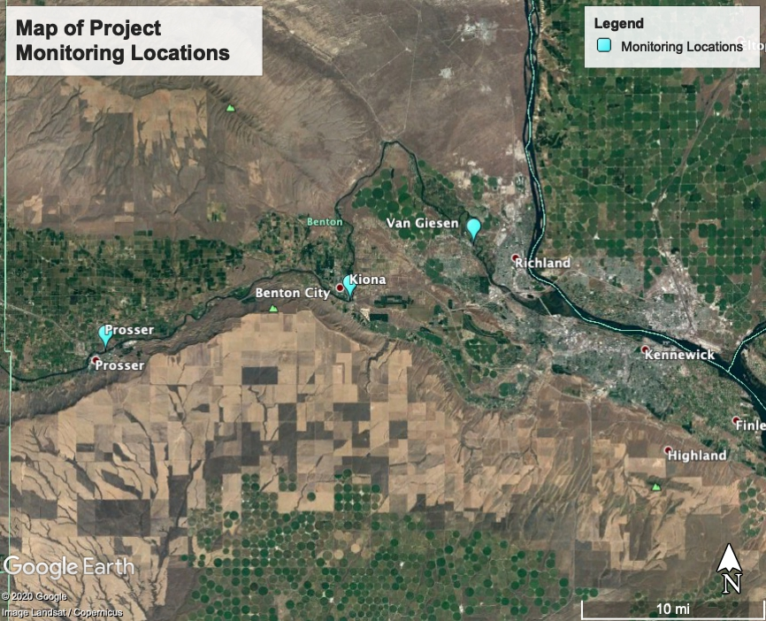

Figure 2. USGS Lower River Water Quality Monitoring locations.

Table 2. USGS Project Study locations.

|  |  |  |  |  |
| --- | --- | --- | --- | --- |
| Location (WA) / USGS NWIS ID | Adjacent Water Body | Property Ownership | Latitude | Longitude |
| Prosser  ID 12509489 | Lower Yakima River | Prosser Waste Water Treatment Plant | 46.2125 | -119.7634 |
| Benton City (Kiona)  ID 12510500 | Lower Yakima River | Benton City | 46.2529 | -119.4777 |
| West Richland (Van Giesen)  ID 12511800 | Lower Yakima River | West Richland, WA | 46.2971 | -119.3334 |

The downstream boundary is located downstream of the Van Giesen Bridge in West Richland. This location is fast flowing, similar to Kiona, but is shallower in depth during the water stargrass growing season. This is lowest USGS monitoring station to date installed within the Yakima River basin providing valuable water quality data.

## 4.2 Sampling and measurement procedures

### 4.2.1 Water quality sampling

We collected flowing water quality parameters using a multiparameter sonde. We used a YSI EXO2 at Kiona and Prosser and a YSI 6920 at Van Giesen. Table 3 displays the water quality parameters collected at each of the three sites. We collected discharge and level at Kiona independent of this project. USGS provided these data through the USGS Kennewick Field Office, but we used them as reference for this project. We also collected level data at the Prosser and Van Giesen locations to provide an indication of water level fluctuations at these sites.

Table 3. Parameters collected at Prosser, Kiona, and Van Giesen (Figure 2).

|  |  |  |  |
| --- | --- | --- | --- |
| Parameter | Prosser | Kiona | Van Giesen |
| Temperature | X | X | X |
| pH | X | X | X |
| Dissolved Oxygen* | X | X | X |
| Specific Conductance* | X | X | X |
| Turbidity* | X | X | X |
| Nitrate plus nitrite* |  | X | X |
| Stage and Discharge* |  | X |  |
| Water Level | X |  | X |

*Indicates parameter is telemetered to the USGS NWIS database in realtime.

As part of the quality control, we collected discrete field samples for nitrate plus nitrite and measurements of field parameters (DO, temperature, pH, specific conductance, and turbidity) at all three of the monitoring locations. These samples are collected for Quality Assurance/Quality Control purposes only. The sampling dates for the discrete field sample measurements are provided in Appendix A and summarized in Table 4.

During site visits, the USGS field technician checks all continuous sensors against a calibrated field meter. This takes place under two conditions: (1) during discrete water quality collection for nutrients and (2) during routine sensor cleaning and maintenance checks. The technician conducts cleaning and calibration visits every 4 to 12 weeks or more frequently if needed (Conn et al. 2017). In addition, the technician conducts visual checks of the telemetered data through the station webpages sub-weekly to identify potential problems (Wagner et al. 2007). No independent turbidity samples were collected for the three gaging stations.

Table 4. Number of Discrete field sample checks at Prosser, Kiona, and Van Giesen for Quality Control.

|  |  |  |  |
| --- | --- | --- | --- |
| Location | No. Samples (2018) | No. Samples (2019) | No. Samples (2020) |
| Prosser  (site 12509489) | 5 | 10 | 9 |
| Kiona  (Site 12510500) | 7 | 17 | 15 |
| Van Giesen  (Site 12510500) | 5 | 11 | 9 |

### 4.2.3 Discrete nutrient analysis QC sample collection

We collected field QC samples for discrete nutrient analysis in addition to the samples collected to ensure proper QC of the continuous monitoring parameters. The discrete nutrient analysis samples included field blanks, field replicates, and equipment blanks. The field blanks are lab-provided inorganic-free water transported from the USGS office in its original container and processed onsite identically to environmental samples and analyzed for dissolved nutrients. The equipment blank is the same as a field blank but processed in the laboratory. The dates for the discrete nutrient analysis samples are provided in Appendix A.

### 4.2.3 Aquatic biomass collection

USGS estimated stargrass biomass once in 2018 (August), three times throughout the 2019 growing season (June, August and September) and twice in 2020 (June and September) at Prosser, Kiona, and Van Giesen. We will compare these biomass estimates to the water quality parameters to determine the interplay of biomass growth on water quality and vice versa. The months and years for the biomass sampling are provided in Table 5, the discrete sample dates are in Appendix A.

USGS determined water stargrass biomass by harvesting all material within a known area. They then dried and reported them as grams dry weight per meter squared. They also collected approximately 10 samples during each time-period to estimate variability within the reach immediately upstream of each continuous water quality station. They rinsed the samples within the river, then bagged and froze them until lab processing.

Table 5. Biomass Sampling Dates.

|  |  |  |  |
| --- | --- | --- | --- |
| Location | Sampling Date 2018 | Sampling Date 2019 | Sampling Dates 2020 |
| Prosser | | | |
|  | August | June | June |
|  |  | August | September |
|  |  | September |  |
| Kiona | | | |
|  | August | June | June |
|  |  | Aug | Sept |
|  |  | Sept |  |
| Van Giesen | | | |
|  | Aug | June | June |
|  |  | August | September |
|  |  | September |  |

After collection, USGS staff dried water stargrass samples at 60°C for 2 – 7 days to determine dry mass per meter squared at each sample location. During the drying process, USGS staff recorded all weights on laboratory data sheets and electronically scanned them to PDF after completion. USGS stores these lab data sheets on a project directory which is backed up daily. They entered data from these sheets into excel to calculate water stargrass biomass, which were then doubled checked by a second member of the USGS field team.

## 4.3 Data management

### 4.3.1 Continuous water quality data

USGS telemeters the data collected at the three continuous water quality stations directly into the NWIS database, providing them to the public as provisional information through the NWIS-web online interface until final. A USGS team member reviews this preliminary data every few days for data gaps from instrument, collection, or telemetry issues. All data for this project are now marked as final in the database and considered complete.

The USGS downloads files directly from the instruments in the field at regular intervals. They validate web data, posted using telemetry, against data from the instrumentation. They also identify and fill data gaps from these direct-download data sets, updating the continuous water quality record in the USGS NWIS-web database.

We store data locally in accordance with the Washington Water Science Center (WAWSC) Data Management Plan and nationally through the NWIS-web interface. Data for this project are not archived in Ecology’s Environmental Information Management (EIM) database as they are stored in the publicly available USGS NWIS database. We generated an EIM number for the project so that the QAPP and data are linked to the project through the Ecology system.

### 4.3.2 Discrete sample data

USGS field technicians record all field data and observations on waterproof paper kept in field notebooks. The staff scan all field notebooks into a PDF format upon returning from the field and transfer information contained in field notebooks to Excel spreadsheets for sample tracking.

Another USGS member of the project team independently verifies data entries for accuracy. That team member uploads field data (values of field parameters, sample conditions, quality control (QC) information, etc.) from each sample trip into the USGS’s [National Water Information System (NWIS) database](https://waterdata.usgs.gov/nwis)[5]. They also upload laboratory data from nutrient analyses into NWIS from National Water Quality Laboratory (NWQL).

The NWQL provides electronic data packages to the Washington Water Science Center (WAWSC) two times a week with water chemistry results for all projects in the center. The WAWSC’s database manager and water quality specialist forward the results to each project manager for review. After reviewing the data package from NWQL, the project manager determines if reruns are necessary and requests the lab to do so. If QC data fall outside of expected ranges, we take corrective actions prior to the next sample trip.

### 4.3.3 Aquatic biomass data

USGS dried water stargrass samples to determine dry mass per meter squared at each sample location. During the drying process, they recorded all weights on laboratory data sheets and electronically scanned them to PDF after completion. These lab data sheets are stored on a project directory which is backed up daily. USGS entered sata from these sheets into excel to calculate water stargrass biomass. Asecond member of the USGS field team double checked them.

# 5.0 Data Quality Control and Assesment

The main data quality objective for this project was to ensure collection of high quality and scientifically defensible continuous water quality data for all study parameters at three monitoring locations on the lower Yakima. We collected these data for comparison to biomass aquatic biomass samples to better understand the dynamics of water stargrass growth and water quality relationships in the lower Yakima.

Measurement Quality Objectives (MQOs) for the measured parameters are provided in Table 6 of the Project QAPP, and provided as Table 6 within this report for quick reference.

Table 6. Measurement quality objectives for field meter measurements.

|  |  |  |  |
| --- | --- | --- | --- |
| MQO | Precision | Bias | Sensitivity |
|  | Comparison to calibrated field meter. | Comparison to standards |  |
| Temperature | Within ±0.2 °C of field meter. | Within ±0.2 °C of NIST calibrated thermistor. | Between -5 and 50 °C, resolution 0.001 °C ±0.01 °C. |
| Specific Conductance | ± 5 uS/cm of ± 3% of field meter, whichever is greater. | Within 5% of standards below 100 uS/cm or within 3% of standards above 100 uS/cm. | Between 0 and 200 mS/cm, resolution 0.001 mS/cm ±0.5% of reading. |
| pH | Within ±0.2 pH unit of field meter. | Within ±0.2 pH unit of at least 2 standards that bracket known range of field measurements. A third standard is used to check the calibration. | 0 and 14 units, resolution 0.01 unit ±0.2 unit. |
| Dissolved Oxygen | Within ±0.3 mg/L or less than 5% of field meter. | Within ±0.3 mg/L or less than 5% of theoretical saturation value at calibration temperature and pressure. | 0 and 50 mg/L, resolution 0.01 mg/L ±0.1 mg/L or 1%, whichever is greater. |
| Turbidity | Within 5% of field meter. | Within 5% of reference solution, or within 0.5 units for a zero reference solution. | Between 0 to 4000 FNU, resolution 0.01 FNU. |
| Nitrate plus nitrite | Checked against discrete field samples, corrected as needed. | Checked against certified inorganic blank water and certified reagent grade standard. | 0 to 28 mg-N/L, resolution 10%, precision ± 0.004 mg N/L. |

In addition to the MQO’s for the field meter measurements, we also adhered to project MQOs for the laboratory analyses of water samples for the measured nutrients. These MQOs are provided in Table 5 of the Project QAPP, and provided below as Table 7 for reference.

Table 7. Measurement quality objectives for laboratory analyses of water samples.

| MQO → | Precision | | Bias | | | Sensitivity |
| --- | --- | --- | --- | --- | --- | --- |
| Parameter | Duplicate Samples | Matrix Spike-Duplicates | Verification Standards (LCS,CRM,CCV) | Matrix Spikes | Surrogate Standardsa | MDLb or Lowest Conc. of Interest |
| Relative Percent Difference (% RPD) | | Recovery Limits  (%) | | | Concentration Units |
| Nitrogen, ammonia | ≤ 20 | ≤ 20 | 90-110 | 80-120 | NA | 0.01 mg-N/L |
| Nitrogen, nitrite | ≤ 20 | ≤ 20 | 90-110 | 80-120 | NA | 0.001 mg-N/L |
| Nitrogen, nitrite + nitrate | ≤ 20 | ≤ 20 | 90-110 | 80-120 | NA | 0.01 mg-N/L |
| Phosphorus, orthophosphate | ≤ 20 | ≤ 20 | 90-110 | 80-120 | NA | 0.004 mg-P/L |

aSurrogate recoveries are compound specific.

bMethod Detection Limit

NA = not applicable, these types of samples are not typically collected for nutrients.

USGS independently collected flow data at the Kiona gaging station, funded through the federal National Water Quality Assessment (NWQA) program outside of this project grant. As such, the QA/QC for these data are not part of this project and are carried out independently by USGS. We will use the flow data, provided on the NWIS database page, to help interpret the relationships between water quality and biomass in the final USGS Investigations Report.

## 5.1 Quality control procedures and data verification

### 5.1.1 Continuous sample data

Data from the continuous water quality monitors are adjusted based on findings from field visits, side-by-side measurements, and discrete lab samples collected for the purposes of quality control for this project. Corrections for fouling or calibration drift applied to the provisional record (as provided on the USGS NWIS-Web) were evaluated independently using data collected during site visits.

USGS staff calibrated the multi-parameter sondes used for measurements of temperature, pH, DO, and specific conductivity during deployment and in the field on the day of each sampling event (Table 3). We compared these values to the listed project MQOs in Table 6. The process for determining bias of continuous field meter measurements follows guidance in Wagner et al. (2007) and the USGS National Field Manual. If the deployed meters are within the calibration parameters in Table 6, a recalibration is not required.

For continuous nitrate sensors, USGS protocols (Pellerin et al. 2013) recommend collecting approximately 20 discrete samples for nitrate plus nitrite each year over a range of flow conditions to calibrate the continuous readings, adjust for shifts, and correct any anomalies.

The MQOs for comparison of data between the field and deployed sensors should fall within the same criteria as those used during calibration (Table 6). If the values for the continuous parameters are outside the limits in Table 6, then the drift and fouling corrections are determined from field maintenance procedures. Drift corrections are based on differences between the field meter and calibration standards and fouling corrections are based on differences in readings before and after cleaning the field meter. In general, linear corrections are applied to the data, but there are a number of situations when these corrections might not be linear based on site specfic condiitons and expert judgement (Wagner et al. 2007). All continuous data available on NWIS marked as approved represents the final corrected data.

The MQO results for the continous monitoring checks for the project data are provided in Table 8. All three station’s records for DO, pH, specific conductance, and temperature are rated as good for the project data. Corrections for fouling or calibration drift applied to the provisional record (as seen on NWIS-Web) were evaluated independently using data collected during site visits and sampling visits. All of these data types are compared against the provisional record and MQOs, referenced in Table 6, during the USGS analysis, approval, and audit procedures. All field check data are available in NWIS for data retrieval.

Table 8. MQOs for continuous monitoring checks at Prosser, Kiona, and Van Giesen.

|  |  |  |  |
| --- | --- | --- | --- |
| Parameter | Number of Verification Samples | Samples in Exceedance | MQOs Met after Correction* |
| Prosser | | | |
| Dissolved Oxygen | 14 | 4 | Y |
| pH | 14 | 0 | Y |
| Specific Conductance | 14 | 2 | Y |
| Temperature | 14 | 0 | Y |
| Kiona | | | |
| Dissolved Oxygen | 18 | 5 | Y |
| pH | 18 | 2 | Y |
| Specific Conductance | 18 | 2 | Y |
| Temperature | 18 | 0 | Y |
| Nitrate + Nitrite | 15 | 1 | Y |
| Van Giesen | | | |
| Dissolved Oxygen | 16 | 3 | Y |
| pH | 16 | 3 | Y |
| Specific Conductance | 16 | 5 | Y |
| Temperature | 16 | 0 | Y |
| Nitrate + Nitrite | 17 | 3 | Y |

*Verification checks are used to adjust continuous data readings. All data meets MQOs after data has been adjusted and corrected by USGS. All continuous data have been rated as good and usable by USGS.

USGS collected discrete nitrate plus nitrite samples roughly monthly over the period of this report; however, times of higher flows impacted sample collection. They accounted for instrument drift by checking the continuous nitrate sensor against known nitrate standards. Although there are continuous nitrate plus nitrite values that fall outside of the MQOs, as listed in Table 7, the nitrate plus nitrite records for Kiona and Van Giesen are rated as good, with applied corrections falling within 15% of discrete samples.

It is of note that the independently collected data for verification of nitrate plus nitrite are depth and width integrated. This may account for the differences between the values collected by the continuous monitor and the reported value from the discrete lab sample. We took these differences into account in the approved record and ensured that continuous data in its final form is representative of the selected cross-section. This will be further discussed in the final USGS investigations report at the conclusion on the project.

### 5.1.2 Discrete nutrient sample data

#### 5.1.2.1 Laboratory analysis quality control assessment

USGS analyzed the nutrient samples at the USGS National Water Quality Laboratory (NWQL) and compared them to internal quality assurance and quality control methods performed by NWQL. NWQL routinely conducts laboratory blanks, laboratory Continuous Calibration Verifications (CCVs), and third party calibration checks (TPCs) according to their quality assurance and control plan. These internal QC samples are determined approximately every 20 samples using guidelines for QC sample frequency from Maloney (2005) and Mueller et al. (2015). While not part of the Centennial funding, USGS included analysis of the orthophosphate fraction as well as the nitrates to examine total nutrients. The QA/QC data are grouped together and included within the results below.

The CCV is prepared from the same source as the calibration standards and is typically one or two of the standards used to calibrate the instrument. These QC samples are used to continuously verify the accuracy/reproducibility of the calibration curve and the instrumentation system. Typically, the CCV is analyzed every 10 to 20 samples to continuously verify accuracy/reproducibility and must continuously meet specific limits (high/low). The TPC is a QC sample prepared from a different source material than the standards used to calibrate. It is typically analyzed once per analysis run. A summary of the results are provided in Tables 9 – 11 below. The values are determined to meet MQOs by comparison to values provided in Table 7.

Table 9. Results from laboratory instrument blanks from June 1, 2018 to Sept 30, 2020. MQOs are provided in Table 7.

|  |  |  |  |  |  |
| --- | --- | --- | --- | --- | --- |
| Parameter | Count | Median value | 95 percent confidence interval | Met MQO? | MDLa or Lowest Conc. of Interest |
| Nitrogen, ammonia | 2988 | 0.0 mg-N/L | 0.00 to 0.01 mg-N/L | Yes | 0.01 mg-N/L |
| Nitrogen, nitrite | 2625 | 0.0 mg-N/L | -0.001 to 0.001 mg-N/L | Yes | 0.001 mg-N/L |
| Nitrogen, nitrite + nitrate | 2979 | 0.0 mg-N/L | -0.03 to 0.03 mg-N/L | Yes | 0.01 mg-N/L |
| Phosphorus, orthophosphate | 3269 | 0.000 mg-P/L | -0.002 to 0.002 mg-P/L | Yes | 0.004 mg-P/L |

aMethod Detection Limit

Table 10. from laboratory continuous calibration verifications from June 1, 2018 to Sept 30, 2020. MQOs are provided in Table 7.

|  |  |  |  |  |  |
| --- | --- | --- | --- | --- | --- |
| Parameter | Count | Mean recovery | 95 percent confidence interval | Met MQO? | MDLa or Lowest Conc. of Interest |
| Nitrogen, ammonia | 5780 | 98% | 91% to 105% | Yes | 0.01 mg-N/L |
| Nitrogen, nitrite | 4941 | 102% | 95% to 108% | Yes | 0.001 mg-N/L |
| Nitrogen, nitrite + nitrate | 5707 | 103% | 97% to 109% | Yes | 0.01 mg-N/L |
| Phosphorus, orthophosphate | 6263 | 100% | 93% to 107% | Yes | 0.004 mg-P/L |

aMethod Detection Limit

Table 11. Results from laboratory third party checks from June 1, 2018 to Sept 30, 2020. MQOs are provided in Table 7.

|  |  |  |  |  |  |
| --- | --- | --- | --- | --- | --- |
| Parameter | Count | Mean recovery | 95 percent confidence interval | Met MQO? | MDLa or Lowest Conc. of Interest |
| Nitrogen, ammonia | 144 | 98% | 91% to 105% | Yes | 0.01 mg-N/L |
| Nitrogen, nitrite | 134 | 101% | 96% to 106% | Yes | 0.001 mg-N/L |
| Nitrogen, nitrite + nitrate | 150 | 102% | 98% to 106% | Yes | 0.01 mg-N/L |
| Phosphorus, orthophosphate | 136 | 101% | 95% to 107% | Yes | 0.004 mg-P/L |

aMethod Detection Limit

#### 5.1.2.2 Discrete nutrient quality control analysis

For discrete nutrient analyses, field QC samples include field blanks, field replicates, and equipment blanks. The field blanks are lab-provided and inorganic-free water transported from the USGS office in its original container and processed onsite identically to environmental samples and analyzed for dissolved nutrients. The equipment blank is the same as a field blank but processed in the laboratory. The data quality objective for blanks was to have no detections of the measured parameters in the blank samples.

For the period of June 2018 through September 2020, a total of six field blanks were collected, two at each of the three monitoring locations. Results showed non-detects for all nutrient parameters measured. A single equipment blank was collected for June 2019 through September 2020, and there was no indication of contamination from field equipment and all measured parameters were non-detects for nutrients.

In addition to the blank samples, USGS collected field replicate samples for nutrients --two at Prosser, three at Kiona, and one at Van Giesen. Replicate results were within the data quality objectives for field replicates with relative percent differences (RPDs) below 20% for all nutrient parameters measured. More specifically, the RPD for nitrite, nitrate plus nitrite, and orthophosphate were less than 5 percent (Table 12). For ammonia, 3 of the 5 replicate pairs were at or below detection the limit of 0.01 mg-N/liter. The other 2 replicates were within 0.02 mg-N/L of each other, and at or below 0.05 mg – N/L. These samples met the project MQOs, as provided in Table 7.

Table 12. Results of field replicates from June 2018 to October 2020.

|  |  |  |  |  |  |  |  |
| --- | --- | --- | --- | --- | --- | --- | --- |
|  |  | **Nitrate plus Nitrite** | | | **Orthophosphate\*** | | |
| **Site** | **Sample**  **Date** | **Sample Value**  **(mg-N/L)** | **Replicate Value**  **(mg-N/L)** | **Relative Percent Difference** | **Sample Value**  **(mg-P/L)** | **Replicate Value**  **(mg-P/L)** | **Relative Percent Difference** |
| Prosser | 3/10/2020 | 1.210 | 1.210 | 0.0 | 0.079 | 0.079 | 0.0 |
| Prosser | 7/7/2020 | 0.773 | 0.788 | 1.9 | 0.064 | 0.064 | 0.0 |
| Kiona | 6/25/2018 | 0.915 | 0.922 | 0.8 | 0.116 | 0.115 | 0.9 |
| Kiona | 3/27/2019 | 0.816 | 0.797 | 2.4 | 0.210 | 0.215 | 2.4 |
| Kiona | 4/15/2020 | 0.460 | 0.455 | 1.1 | 0.115 | 0.119 | 3.4 |
| Van Giesen | 8/20/2020 | 1.020 | 1.030 | 1.0 | 0.093 | 0.093 | 0.0 |

*Orthophosphate was collected independtly by USGS with external funding outside of this funded project, but results were analyzed with the nitrate plus nitrite samples and provide a more comprehensive look at nutrient dynamics and as such are included in the reporting.

The QC data for the discrete nutrient samples show that field sampling has no measurable contamination and has a low amount of variability in nutrient concentrations giving the data user confidence the data is of excellent quality.

### 5.1.3 Aquatic biomass quality control assesment

For aquatic biomass collection, USGS assessed site variability by collecting up to 10 samples of water stargrass per station. Dry weights of these samples are confirmed by reweighing all plant samples multiple times over several days to ensure that final dry weight has been achieved. Weighing stopped after subsequent dry weights were within 0.5 grams of each other. Replication of point measurements in the field to document presence/absence of water stargrass was assessed a single time at Kiona in August 2019. The data quality objective for estimating presence/absence of water stargrass from a given transect was +/- 20%. Field replication was determined by having two different observers conduct point counts at the same transect. The result from this showed that each observer was within 10% or each other, indicating that field methods for documentation of water stargrass presence repeatable within the project data objectives.

## 5.2 Field conditions

The USGS team encountered some weather related difficulties in accessing equipment for routine maintenance and field checks during the reporting period in 2018 – 2019 due to anomalous late season snow pack. Seasonal weather patterns were more typical in 2019 – 2020; however, the Covid-19 pandemic started during this monitoring year, which resulted in a statewide shutdown on March 13, 2020.

The Covid-19 shutdown caused delays with field work and sample collection until Covid-19 safe sampling protocols were put in place and fieldwork could resume. While we also experienced extreme heat events and poor air quality from state fires during this project period, they did not greatly impact the data or collection. There were no significant flood or drought events during the project collection period. While there were unusual events that delayed or impacted field sample collections, the recommended number of field visits for continuous water quality were maintained and the data quality was not impacted as a result.

In addition, there were multiple times during the multiyear data collection where data was lost from the continuous monitoring stations. Data losses resulted from equipment malfunctions, bad sensors, and high flows where static tubes were buried in sediment. Effort was made to minimize the time periods of data loss and are summarized for each station below (Table 13).

Table 13. Summary of data gaps in continuous water quality records for all stations from June 2018 to October 2020.

|  |  |  |  |
| --- | --- | --- | --- |
| Parameter | Prosser | Kiona | Van Giesen |
| Temperature | 6/16/20 - 7/21/20 | 10/14/19 – 11/5/19 | 11/28/18 – 12/10/18  12/19/18 – 1/16/19 |
| Dissolved Oxygen | 6/16/20 – 7/21/20 | 10/14/19-11/5/19  2/14/20 – 3/5/20 | 11/28/18 – 12/10/18  12/27/18 – 1/16/19  6/11/19 – 10/31/20 |
| Specific Conductance | 6/16/20 – 7/21/20 | 10/14/19 – 11/5/19 | 11/28/18 – 12/10/18  12/31/18 – 1/16/19 |
| pH | 4/14/19 – 6/26/19  6/16/20 – 7/21/20 | 10/14/19 – 11/5/19  3/3/20 – 4/8/20 | 11/6/18 – 4/3/19  6/19/19 – 6/24/19 |
| Turbidity | 6/16/20 – 7/21/20 | 7/10/19 – 8/8/19  10/14/19 – 11/5/19  7/2/20 – 8/21/20 | 11/27/18 –1/16/19 |
| Nitrate | not collected | -- | 11/27/18 – 12/10/18  1/1/19 – 1/16/19  2/6/20 – 10/31/20 |

# 6.0 Results and Analysis

## 6.1 Water quality dynamics

The USGS project team continuously monitored water quality parameters on the lower Yakima River from June 2018 – October 2020 (Prosser and Kiona) and from August 2018 – October 2020 (Van Giesen Bridge). They collected biomass estimates one time in 2018, three times during the 2019 growing season, and twice during the 2020 growing season. The water quality data results are presented below for the completed project data set and the implications for meeting water quality objectives within the lower Yakima are discussed.

We found the data usability and quality to be good, meeting the project MQOs, as discussed in Section 5.0. The water quality data were determined to be the right type, quantity, and quality to meet the study objectives in Table 6. USGS provides an in-depth results analysis and discussion of the project water quality data in relationship to the water stargrass biomass dynamics in a *USGS Scientific Investigations Report* (Sheibley et al. 2022), which is part of the final project deliverables for this grant work.

This final report is to document QA/QC, provide the water quality project results as related, and provide initial discussion on the implications for water stargrass biomass.

### 6.1.1 Flow

The 2018 – 2020 field seasons were within normal ranges for the median water years within the lower Yakima (Figure 3 and Figure 4). Flows peaked in the spring (March – April) with baseflow conditions from June – August for all water years, as typical for the lower river. On average, river flows and water level at Kiona were lower during the peak growing season of 2019 than that of 2020. In 2020, we obsesrved higher river flows later into spring than in 2019.

The ambient average air temperatures during the 2018 – 2020 project reporting are provided in Figure 5. The air temperatures are recorded by WSU AgWeather at Benton City, East Station. The annual average temperatures in 2020 were slightly warmer than those observed for 2019. The average maximum temperature for 2020 was 67.9°F at the Benton City, East station versus 63.6°F in 2019.

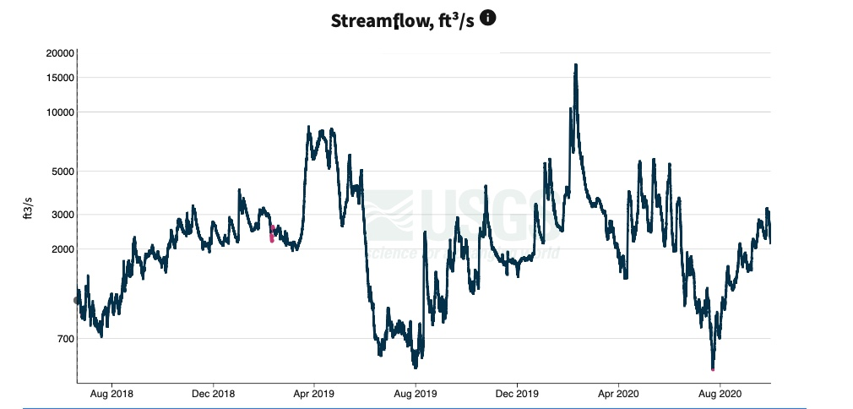

Figure 3. Flow as measured at Kiona in feet for the project reporting period. Data from [waterdata.usgs.gov](https://waterdata.usgs.gov/monitoring-location/12510500/#parameterCode=00065&period=P7D).

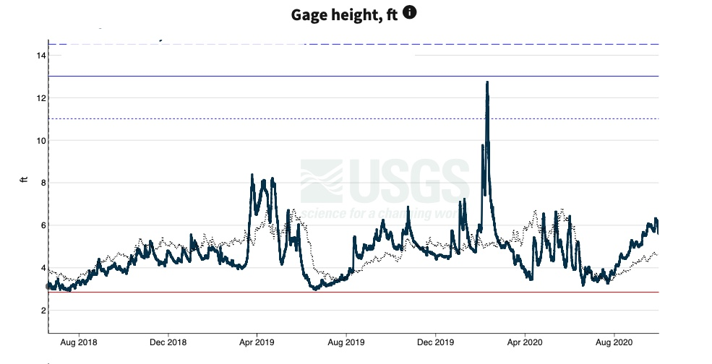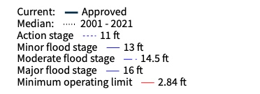

Figure 4. Gage Height at Kiona in feet for the project reporting period. Data from [waterdata.usgs.gov](https://waterdata.usgs.gov/monitoring-location/12510500/#parameterCode=00065&period=P7D).

#### 

Figure 5. Ambient Air Temperature (Benton City, E) near Kiona gage. Data are from the WSU AgWeatherNet monitoring database ([weather.wsu.edu](https://weather.wsu.edu/?p=92850&desktop)).

### 6.1.2 Water temperature

Figure 6 shows the daily maximum temperatures for all three monitoring locations during the project monitoring period. The daily maximum measured temperatures at Prosser are slightly cooler during the summer months as compared to daily maximum temperatures at Kiona and Van Giesen indicating downstream warming. Daily maximum temperatures at Prosser, however, are still well above the state standard of 21°C during baseflow conditions.

Observed water temperature data at all three locations for 2018 – 2020 are typical of current river conditions for the lower Yakima River. The Yakima River is highly regulated with large irrigation demands placed on the river during summer baseflow conditions. River stage decreases rapidly in late spring as ambient air temperatures begin to rise and irrigation demands increase (as shown above in Figure 4). Subsequently, lower Yakima River water temperatures increase in late spring with increasing solar radiation and lower flows. Temperatures typically exceed the state standard of 21°C for the summer months during late June through late August.

The number of days when the maximum daily temperature exceeded the 21°C criteria were similar across all sites for water years 2018 through 2020 (Table 14). Water year 2019 had the most days in exceedance of the three summers monitored. Even though average ambient air temperatures were higher in 2020, 2019 had lower sustained river baseflows than observed in 2020.

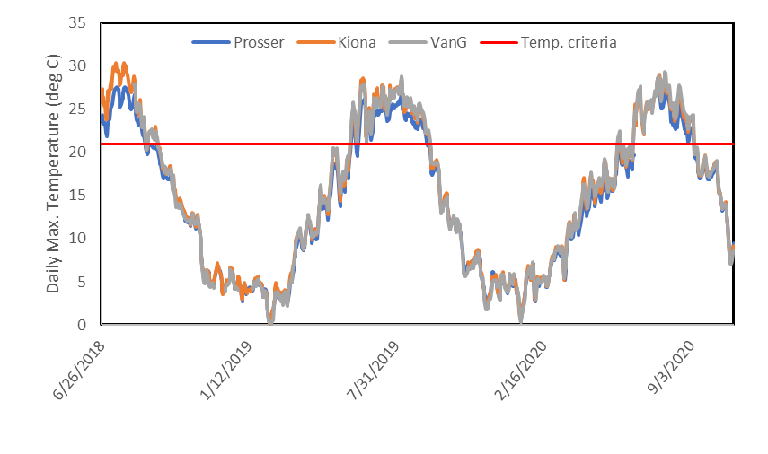

Figure 6. Daily maximum temperature at Prosser, Kiona, and Van Giesen monitoring stations.

Table 14. Summary of the number of days of 1-Day Max Exceedances by year across all stations. WY 2018 was a shorter season with the first year of sonde deployment.

|  |  |  |  |
| --- | --- | --- | --- |
| Site | WY 2018 | WY 2019 | WY 2020 |
| Prosser | 60 | 108 | 48**\*** |
| Kiona | 75 | 101 | 86 |
| Van Giesen | 31+ | 109 | 87 |

*Missing data for 33 days in summer

+ Started 6 weeks later in 2018

Analysis of the temperature data indicates a clear downstream warming trend during the summer months between Prosser and Kiona (Figure 7). Temperature is a critical parameter for salmon survival and success in the lower Yakima. Adult and juvenile salmonid migrants pass through the lower Yakima during their migration from the headwaters of the Cascade Mountains to the central valley Columbia River twice in their lifetime. For migrants who pass through the Yakima River during the end of spring or summer (sockeye, steelhead, summer chinook), the river temperatures become inhospitable, especially below Benton City (Kiona). These temperatures can be detrimental to their survival and migratory success rates.

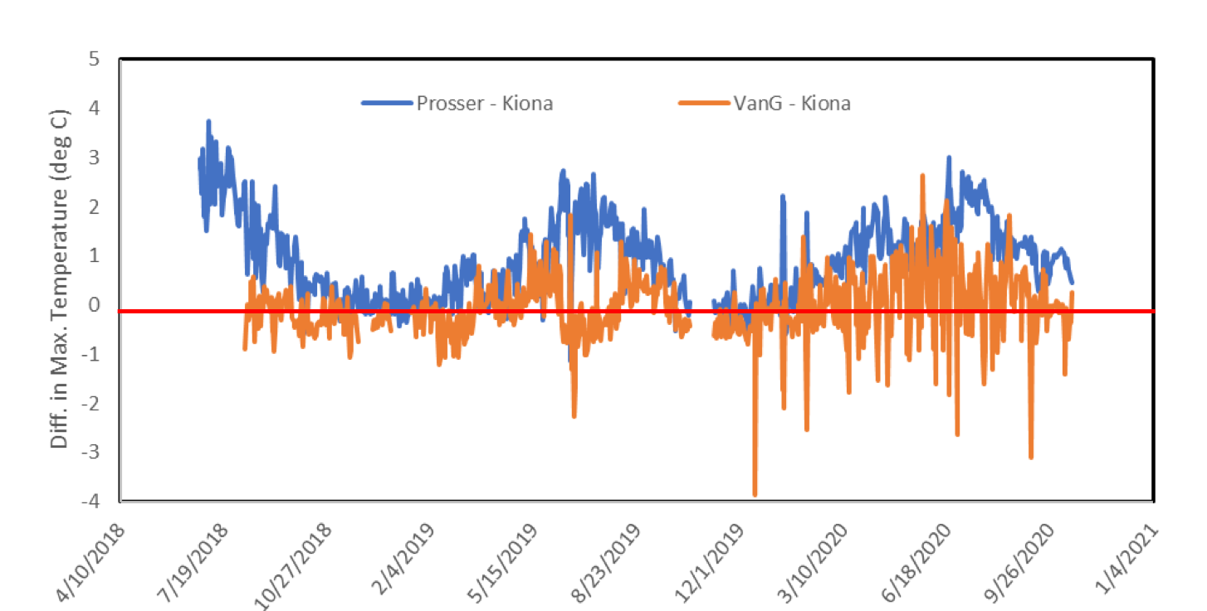

Kiona-Prosser

Figure 7. Differences in Maximum Temperatures between Kiona and Prosser and Kiona and Van Giesen showing downstream warming trends.

### 6.1.3 Dissolved oxygen

The DO criterion for the lower Yakima is a 1-day minimum of 8 mg/L (Ecology 2019). *{Note DO data after June 2019 was removed for Van Giesen from the project analysis after additional review of the data set, as discussed further in Section 6.3}.* The DO for Prosser and Kiona monitoring sites fell below the daily DO minimum standard at various times during the 2018 - 2020 monitoring period (Figure 8 and Table 15); with minimums most often occurring during the summer baseflow conditions. The range (or variability) in daily DO is greatest in the late spring and summertime. The Kiona gauge often showed a greater range of DO, than observed at the Prosser gauging stations.

Diurnal (daily) fluctuations in DO are common in rivers due to in-river photosynthesis processes where photosynthesis occurs during the day (increasing DO levels) and respiration occurs at night (decreasing DO levels). While normal, the large fluctuations resulting from this daily cycle can cause drops in DO levels at night that exceed the state’s minimum water quality criterion of 8 mg/L. The Kiona monitoring station consistently showed the lowest DO levels during the growing seasons with the greatest daily fluctuations (Figure 9). High daily fluctuations are indicative of aquatic plant photosynthesis and respiration as a primary driver at Kiona.

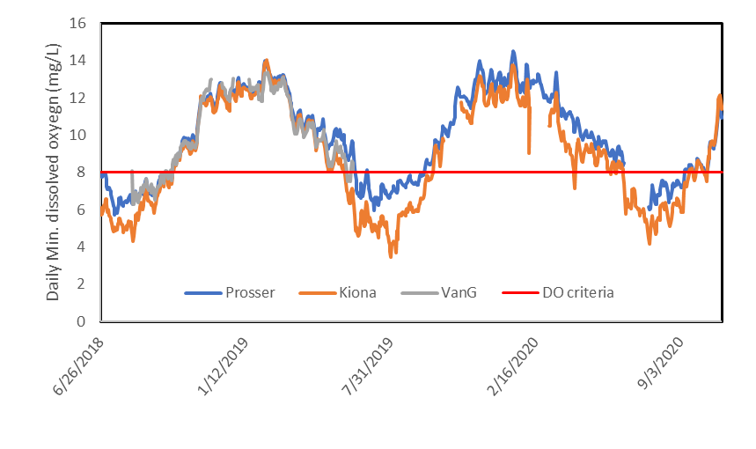

Figure 8. Daily dissolved oxygen minimum at Prosser, Kiona, and Van Giesen.

Table 15**.** Number of days when dissolved oxygen was less than 8.0 mg/L.

|  |  |  |  |
| --- | --- | --- | --- |
| Site | WY 2018 | WY 2019 | WY 2020 |
| Prosser | 97 | 97 | 52**\*** |
| Kiona | 97 | 124 | 110 |
| Van Giesen | 49+ | 7** | No Data |

*missing data for 33 days in summer

**missing 112 days in water year 2019

+ Started 6 weeks later in 2019.

Understanding the relationships between biomass respiration and photosynthesis on the lower Yakima DO levels are vital to our basin wide efforts in restoring summer salmon stocks. Continuous monitoring of the lower river highlights that during baseflow conditions and peak biomass growing season we have locations that fail to meet the minimum daily DO criterion and the maximum temperature criterion. Late spring and summer adult migrants, who are exposed to thermal stress during the day, may encounter added stress from low DO levels during their movement at night. This creates a dire situation for adult salmon migrants.

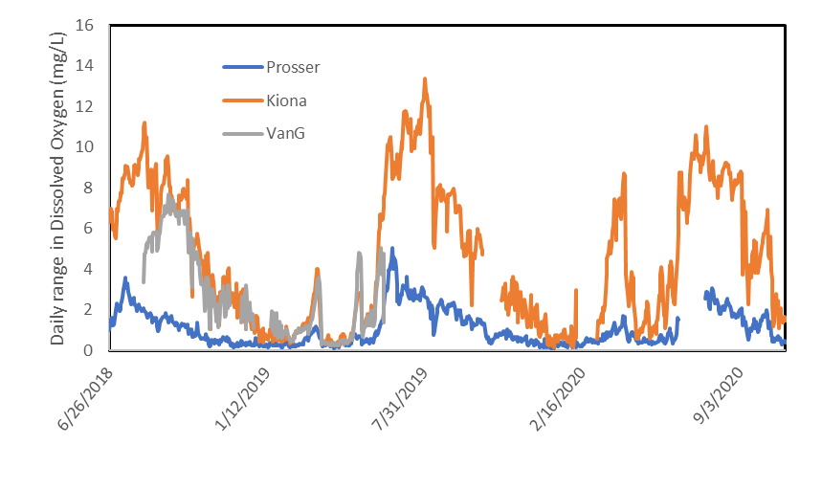

Figure 9. Daily dissolved oxygen range at Prosser, Kiona and Van Giesen.

### 6.1.4 pH

Lower Yakima pH levels for aquatic life uses must fall in the range of 6.5 to 8.5 pH units with a human caused variation within this range of less than 0.5 pH units (Ecology 2019). Continuous pH values were monitored at all three sites for the 2018 – 2019 monitoring period. The graphs for the daily minumum and maximum pH at Prosser, Kiona (Benton City), and Van Giesen (West Richland) are provided in Figures 10 – 11.

Both Kiona and Van Giesen monitoring locations exceeded the maximum water quality criteria for pH of 8.5 pH units from June through September in 2018, 2019, and 2020 with additional exceedances in the winter and spring of 2020. Prosser remained between the water quality criteria of 6.5 – 8.5 pH units most of the recording period, except for a few days in the middle of June 2019 and summer of 2020 when the pH rose above 8.5.

None of the sites fell below the minimum water quality criteria of 6.5 during the 2018 – 2020 monitoring period. Washington State’s list of impaired waterbodies under Section 303(d) of the Clean Water Act lists the Lower Yakima as impaired for pH and this is indeed indicated in the project data collected from 2018 – 2020.

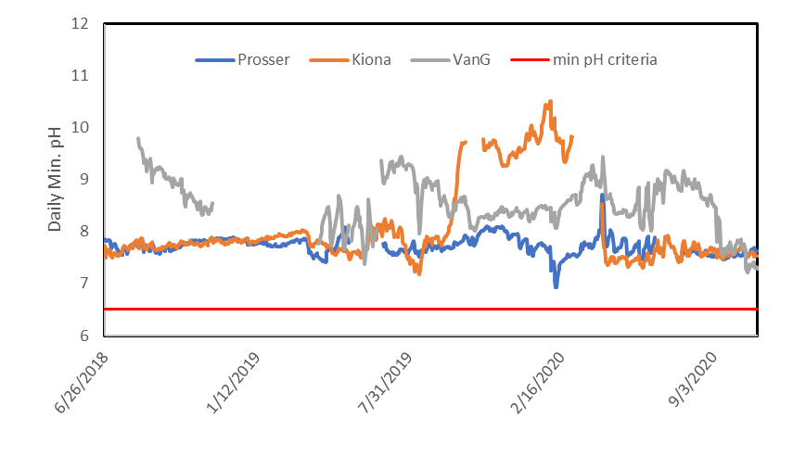

Figure 10. Daily minimum pH values for all stations compared to the minimum criteria of 6.5.

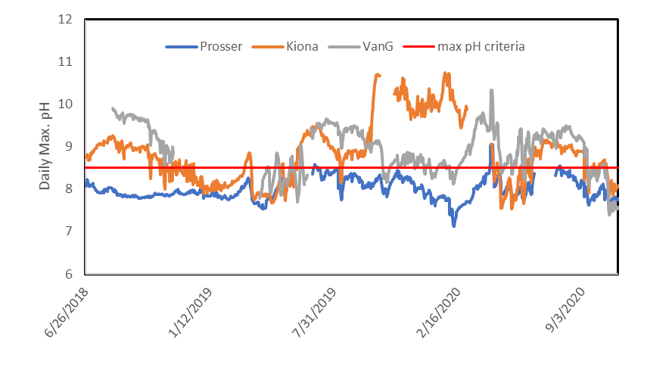

Figure 11. Daily maximum pH values for all stations compared to the maximum criteria of 8.5.

The daily pH range shows a seasonal sinuosity for all three sites (Figure 12). The amplitude of the daily range of pH was greatest during baseflow conditions (late spring to early fall), which coincides with the growing season for aquatic primary producers. The largest swings in pH were observed at Kiona, similar to patterns observed with the daily DO data. A more in depth analysis of pH and its relationship to aquatic plant growth will be included in the final *USGS Scientific Investigations Report* (Sheibley et al. 2022).

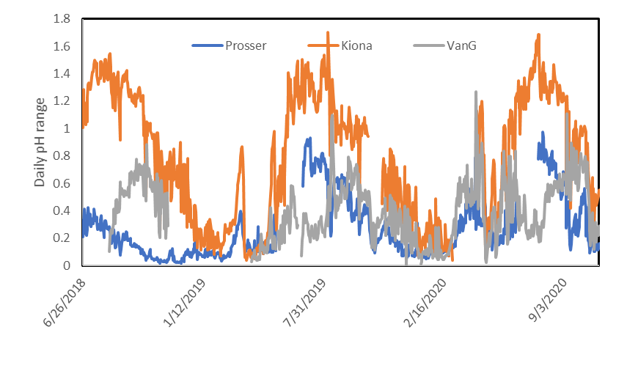

Figure 12. Daily range in pH across the three monitoring locations from June 2018 to October 2020.

### 6.1.5 Turbidity

The maximum water quality criteria for turbidity in the lower Yakima is no more than 5 nephelometeric units (NTU) over background when background is 50 NTU or less. Continuous monitoring of turbidity by the USGS gaging station equipment is measured in Formazin Nephelometric Unit (FNU) instead of Nephelometric Turbidity Unit (NTU). Unfortunately there is no way to directly convert between NTU and FNU as the units are the result of inherent properties of the wavelength of the light source used to measure the light scatter. However, both units are nephelometric measures as both use light scattered at 90 degrees from the incident light beam. Therefore, the readings are essentially the same for the purposes of comparing to the water quality criteria. It is a reasonable assumption that the measured turbidity in FNU is comparable to NTU.

Plots of the maximum daily values of turbidity at Prosser, Kiona, and Van Giesen are provided in Figures 13 to 15. Background turbidity at all three sites were well below 50 FNU with average values for the period of study of 5, 13, and 1 FNU at Prosser, Kiona, and Van Giesen, respectively. Monitoring of the lower Yakima River turbidity indicates that there are days when maximum turbidity exceeds 5 FNU over background at all three sites, but predominantly the FNU values are well below this criteria during the monitoring period. Temporary violations are observed; however, they are short term with levels dropping quickly back to background levels.

Prosser turbidity levels more frequently exceeded the criteria than Kiona and Van Giesen. The maximum values at Prosser were often much lower throughout the monitoring period than Kiona. Although, turbidity falls primarily within the water quality criteria, it is important to look at the variability between seasons and sites and the timing of the number of days of exceedences (such as the relationship of increases or seasonality to rain events and/or reservoir releases).

Turbidity can have an impact on light availability and macrophyte growth. Removal of high levels of suspended sediments in the early 2000s improved light clarity and water quality in the lower Yakima as suspended solids predominantly originated from Yakima Basin agricultural lands and carried pesticides, chemicals (PCBs), and nutrients (nitrogen and phosphorus). While the concerted basin wide efforts decreased levels of suspended sediments and toxins to the lower river, it also improved light availability that is likely to contribute to the abundant plant growth. While not part of the funded work by Ecology, USGS independently measured photosynthetically active radiation (PAR) at the lower river monitoring sites to examine light availability and biomass growth. USGS will evaluate these data in the final USGS Investigations Report provided in spring of 2022.

While high levels of suspended sediments and turbidity can be deterimental for fish respiration, some level of increased turbidity can help provide cover from predators for migrating juveniles. Fish will typically move with timed reservoir releases and storm events, which carry increased suspended sediment loads. While we see large spikes in the measured FNU levels above background at all three sites periodically during the monitoring period, they are unlikely to be a cause for concern given the rapid return to background level. A more in depth analysis of turbidity, PAR, and the relationship to aquatic plant growth will be included in the final *USGS Scientific Investigations Report* (Sheibley et al. 2022).

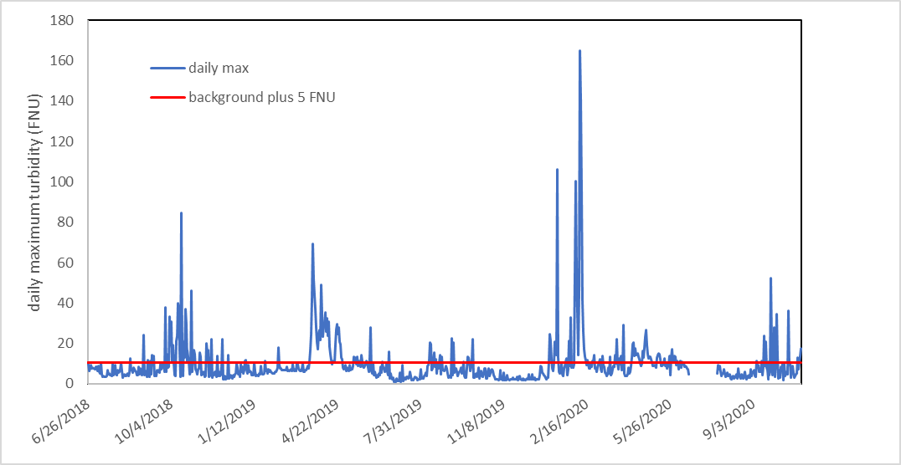

Figure 13. Maximum daily turbidity at Prosser from June 2018 to October 2020. The red line indicated the background value plus 5 FNU (FNU = 10).

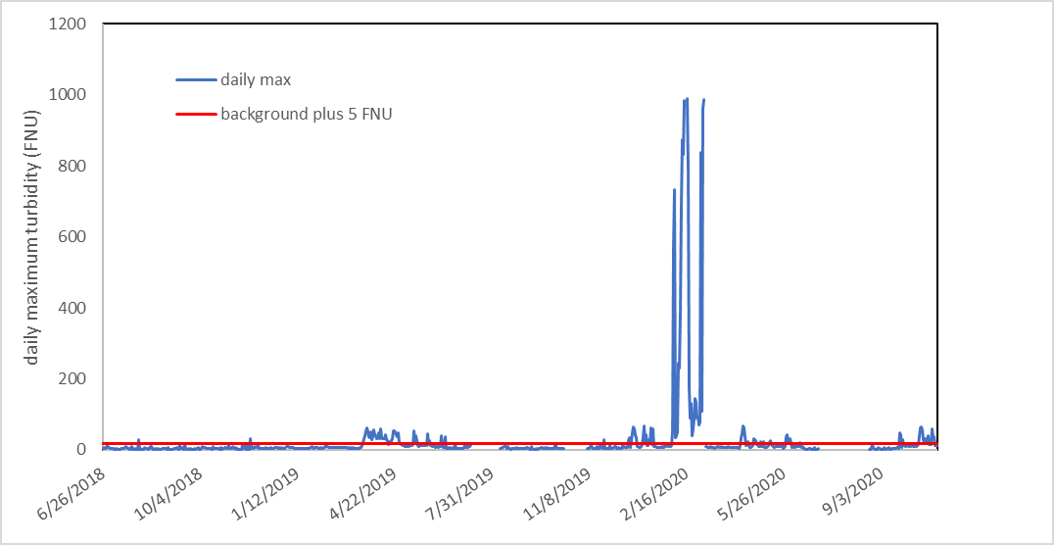

Figure 14. Maximum daily turbidity at Kiona from June 2018 to October 2020. The red line indicated the background value plus 5 FNU (FNU = 18).

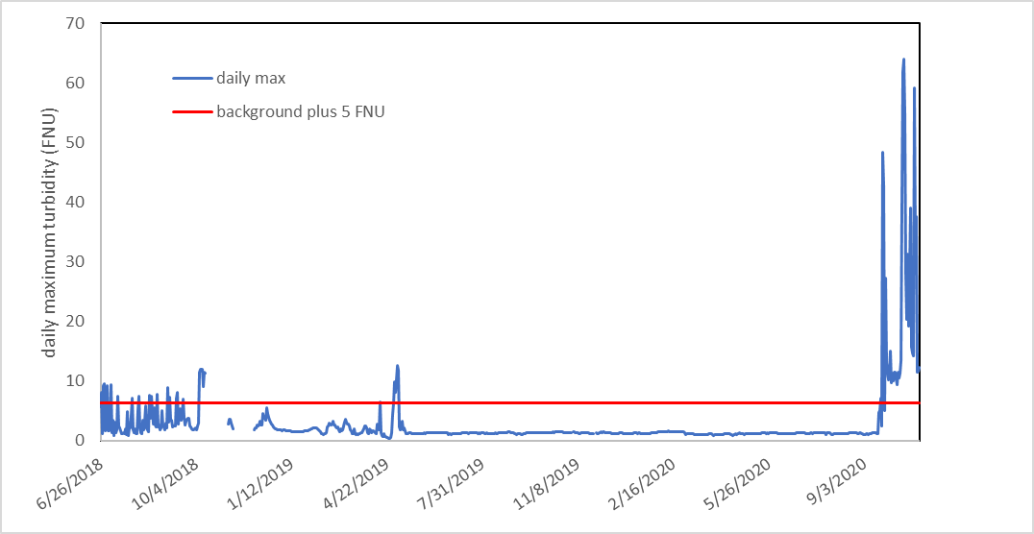

Figure 15. Maximum daily turbidity at Van Giesen from June 2018 to October 2020. The red line indicated the background value plus 5 FNU (FNU = 6).

### 6.1.6 Nitrates, nitrites, and orthophosphates

There is no established nitrate level for the lower Yakima. However, the continuous nitrate plus nitrite ranges were predominantly below 2.0 mg-N during the monitoring period, which is surprisingly low for the agricultural river system (Figure 16). While not part of the contracted scope of work for this project, USGS also analyzed the discrete samples for the orthophosphate fraction. Similar to nitrate plus nitrites, the orthophosphate levels are also low across all three monitoring sites (Table 16).

Table 16. Summary of discrete nutrient data collected at the monitoring locations from June 2018 to October 2020.

|  |  |  |  |  |  |
| --- | --- | --- | --- | --- | --- |
|  | Nitrate plus nitrite (mg – N) | |  | Orthophosphate (mg – P)* | |
|  | Median | Range |  | Median | Range |
| Prosser | 1.2 | 0.4 – 1.86 |  | 0.07 | 0.03 – 0.12 |
| Kiona | 0.93 | 0.4 – 1.79 |  | 0.06 | 0.03 – 0.10 |
| Van Giesen | 1.0 | 0.5 – 1.87 |  | 0.07 | 0.03 – 0.10 |

*Orthophosphate was collected independtly by USGS with external funding outside of this funded project, but results were analyzed with the nitrate plus nitrite samples and provide a more comprehensive look at nutrient dynamics and as such are included in the reporting.

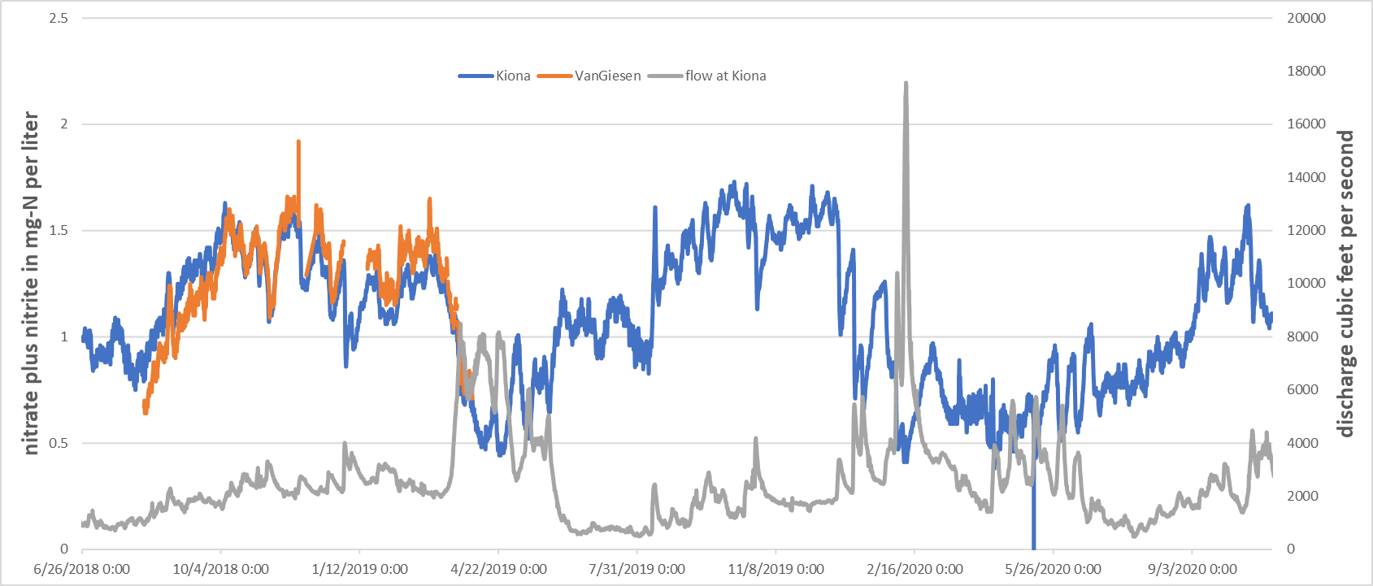

Figure 16. Continuous Nitrate+Nitrite at Kiona and Van Giesen compared to discharge as measured at Kiona (Benton City,WA).

Initial results for the nutrient data highlight the importance of continuous data in investigating nitrate trends. The nitrate levels are highest during the late fall and early winter months, with nitrate levels declining in the late winter through early spring. There are multiple processes at play that might be involved in these trends including seasonal hydrology, groundwater-river processes, irrigation and biomass growth. The nutrients within the sediment bed and hyporheic zone were not examined as part of this study and future work may be needed to investigate the cycling of nutrients between the sediment bed, biomass, and water column. However, there is evidence that surface water nitrates play a role in water stargrass biomass growth. Plotting data from Kiona for a 1-week period from August 1 through 7, 2018 there is a distinct dirunal pattern in dissolved oxygen, pH, and nitrates (Figure 17). During the day when pH and DO increase from photosynthesis, we see a decrease in nitrate plus nitrite indicating that surface water to some extent may play a role in WSG growth. It is important to note that Kiona also had a lot of filamentous algae present on cobbles between areas of water stargrass. So the changes observed in Figure 17 represent a combined effect of the whole aquatic plant community. A more in depth analysis of nutrients and its relationship to primary productivity is included in the final *USGS Scientific Investigations Report* (Sheibley et al. 2022).

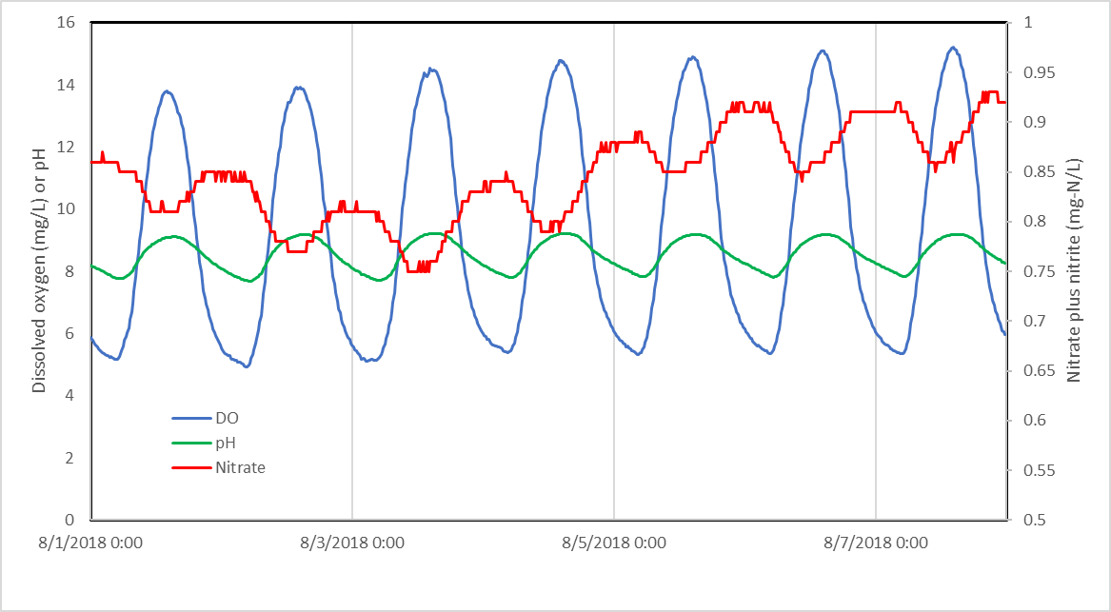

Figure 17. Continuous dissolved oxygen, pH, and nitrate from August 1st through 7th 2018 as measured at Kiona (Benton City, WA).

## 6.2 Water stargrass dynamics

USGS collected percent cover and biomass estimates for water stargrass at all three sites in August 2018, June, August, and September of 2019 and June and August of 2020 (Table 17). Biomass estimates are determined from multiple plant samples harvested from a known area and then dried in the laboratory to a constant weight; with the areal biomass provided as a dry weight per unit area.

Table 17. Results for water stargrass biomass from August 2018.

|  |  |
| --- | --- |
| Location | Dates of Biomass Sampling |
| 2018 | 8/14 – 8/16 |
| 2019 | 6/25 – 6/27;  7/31 –8/1;  9/18 |
| 2020 | 6/27;  8/10 – 8/11 |

### 6.2.1 Biomass growth between years

Yearly water stargrass biomass data are summarized in Tables 18, 19, and 20 for the three sampling locations of Prosser, Kiona and Van Giesen. Data collections from each sample visit took place during a 1-2 day period in order minimize changes from flow or weather across the 3 sample locations. Prosser had the greatest areal biomass (measured as dry weight per unit area) for all three monitoring seasons; however, Kiona had the greatest percent cover. Van Giesen had the lowest percent cover and the lowest areal biomass for all three monitoring seasons.

Table 18. Results for water stargrass biomass from August 2018.

|  |  |  |
| --- | --- | --- |
| Location | Percent cover | Areal Biomass  (dry weight per unit area) |
| Prosser | 48 | 1422 g/m2 |
| Kiona | 62 | 360 g/m2 |
| Van Giesen | 27 | 412 g/m2 |

Table 19. Average water stargrass biomass from June through September 2019.

|  |  |  |
| --- | --- | --- |
| Location | Percent cover | Areal Biomass  (dry weight per unit area) |
| Prosser | 70 | 6,600 g/m2 |
| Kiona | 80 | 1,300 g/m2 |
| Van Giesen | 35 | 1,000 g/m2 |

Table 20. Average water stargrass biomass from June through August 2020.

|  |  |  |
| --- | --- | --- |
| Location | Percent cover | Areal Biomass  (dry weight per unit area) |
| Prosser | 54 | 2,545 g/m2 |
| Kiona | 75 | 802 g/m2 |
| Van Giesen | 22 | 771 g/m2 |

Water stargrass biomass estimates are variable across sites and this trend continues for all sampling seasons. The differences in areal biomass are likely the result of differences in the physical characteristics of each sample reach. For example, the channel at Prosser is deeper, and flow velocity slower than the other two sites. This allows the water stargrass to grow into much bigger plants, some often exceeding 4 feet or more in length.

Comparing this to Van Giesen, where the channel is much shallower, flow velocities are higher, and deeper pools are not frequently detected. As such, large water stargrass plants are not commonly found. Kiona represents a middle condition to the other two sites. The percent cover at Kiona is much greater, likely because the channel here is relatively uniform. There are not many really shallow or deep spots at Kiona, depths are on average 1-2 feet deep, and velocity is swift, but likely not great enough to hinder or scour plants once they become established. Hydrology seems to greatly influence the amount and size of plants measured at each site.

Areal biomass in 2019 was greater than in 2020 at all three sites. Water year 2019 had lower sustained baseflows than observed in Water Year 2020. Water temperatures were also warmer in 2019 with more days of exceedances over the 21°C threshold. In addition to site specific hydrology impacting biomass at each site, we surmise that yearly variations in basin hydrology also impact the total yearly biomass production.

Box Plots of the water stargrass biomass at Prosser, Kiona, and Van Giesen are provided in Figures 17, 18, and 19, respectively for the 2018, 2019, and 2020 peak growing seasons. The peak growing season for this project was considered June through September. Only one collection occurred for the 2018 sampling season due to delayed timing with the initial project contracting. The 2020 pandemic shutdowns impacted the 2020 sampling season, with biomass collected only twice – once in June and once in August.

At Prosser we see increasing areal biomass with the duration of the peak growing season from June through September for 2019 and June through August of 2020. A decrease in measured biomass is observed between the end of the growing season (August) and the start of the following growing season (June) (Figure 18). The biomass measured at this site followed what we would anticipate for a typical perennial aquatic plant growing cycle; a measurable increase in biomass over the growing season, and a resetting of the plant community during high water periods during the non-growing season.

Kiona and Van Giesen had deviations from the anticipated seasonal biomass growth pattern (Figures 19 and 20). At Kiona the data showed an increase in biomass during the 2019 and 2020 growing seasons, but there was not a resetting of biomass between the August 2018 sampling event and the new growing season in June of 2019. This resetting was observed as expected between the end of the 2019 season and the start of the 2020 growing season. Biomass at Van Giesen increased over the course of the 2019 growing season, but unexpectedly decreased during the second growing season between the June and August 2020 sampling events. The deviation of the expected growth patterns at Kiona and Van Giesen could indicate factors other than changes in flow are important and the sensitivity of each site to seasonal flow patterns is variable.

Figure 18. Box Plots of Water stargrass Biomass at Prosser. Box plot order from left to right: August 2018, June 2019, August 2019, September 2019, June 2020, August 2020. Boxes with the same lower case letters are considered to not have a statistically significant difference from each other.

Figure 19. Box Plots of Water stargrass Biomass at Kiona. Box plot order from left to right: August 2018, June 2019, August 2019, September 2019, June 2020, August 2020. Boxes with the same lower case letters are considered to not have a statistically significant difference from each other.

Figure 20. Box plots of water stargrass biomass at Van Giesen. Box plot order from left to right: August 2018, June 2019, August 2019, September 2019, June 2020, August 2020. Boxes with the same lower case letters are considered to not have a statistically significant difference from each other.

### 6.2.2 Biomass relationships

We anticipate the differences in growth patterns observed at each site to be a reflection of the differences in site specific hydrology coupled with differences in hydrology between water years. Water years with an earlier peak in the spring freshet, and lower sustained baseflows tend to yield greater summertime biomass at all sites (as seen in 2019). While all three sites experience the same type of water year, the site specific hydrology characteristics will create variability in annual biomass growth patterns. Prosser is deeper than Kiona and Van Giesen, and this increase in depth may influence light availability early in the spring, attenuating initial early plant growth. However, even with the greater depth, the consistently slower flows at this site result in a significantly larger biomass yield than measured at Kiona and Van Giesen.

Van Giesen, has the swiftest water of the three sites sampled. While similar in depth to Kiona, there is a greater potential for bed scour and sheer stress at this location at higher flows. The potential for swifter flows, especially in higher flow water years, may result in the variability observed within the different growing seasons. Moderately higher flows in 2020 may have resulted in the swifter waters attenuating or flushing out biomass growth as compared to the lower sustained flows observed in 2019.

These same differences in hydrology also tend to play out in how the plant biomass impacts the daily range in DO. As noted in Section 6.1.3, Prosser has a smaller daily range of DO, but contains the greatest amount of plant biomass. It is likely that the added water column height above the large volume of plant biomass at Prosser attenuates the daily rate of change in DO caused by plant photosynthesis/respiration. Kiona has a smaller total amount of plant biomass than Prosser, but has a higher daily rate of change in DO values. The channel at Kiona is shallow and the emergent plant biomass at Kiona, versus primarily submergent at Prosser, greatly influences the daily DO swings during baseflow conditions.

Based on observations in an Ohio stream, water stargrass growth ceases in the autumn or early winter when water temperatures fall to 10 °C and resumes in the late winter or early spring when water temperatures reach 8 °C (Horn 1983). With a low water temperature threshold for breaking plant dormancy, water stargrass has an early and sustained growing season in the lower Yakima. Observationally, Prosser has the lowest temperatures of the three monitoring locations, but the greatest areal biomass. Temperature is not a limiting factor in the lower Yakima for water stargrass growth. Higher water temperatures, however, may be exasperated by biomass growth. At Kiona where there is high coverage of dense channel spanning emergent plant growth, flows are impacted and slowed. As such, the water stargrass may indirectly cause additional warming exacerbating already warm waters. A refined analysis of differences in biomass growth at the different sites as relating to water temperature will be provided in the final *USGS Scientific Investigations Report* (Sheibley et al. 2022).

The continuous nutrient data for the 2018 – 2020 monitoring years was surprisingly low for the agriculturally dominated Yakima Basin. However, the data show there is a dirunal pattern between DO, pH, and nitrates indicating that some nutirent uptake directly by the water stargrass may be taking place. In this case, the plant population may have an effect on nutrient concentrations in the water. If plants obtain at least some of their nutrient supply from the water column, they may be helping to keep nutrient levels low or acting as a nutrient sink. Furthermore, nitrate reduction strategies in the basin might help keep water stargrass growth in check. More work will need to be performed to evaluate the relationships between nutrient cycling and water stargrass, including investigations of nitrate levels in the sediments and hyproheic zone. While investigating nutrient levels in the sediment is outside of this project scope, some of this work is underway by Washington State University – Tricities. These are important questions to address when thinking about management techniques for water stargrass.

## 6.3 Data issues

The only project data issues were at the Van Giesen monitoring station. There was a delay in the installation of the Van Giesen monitoring station while securing permission from the City of West Richland to install equipment on their property. As such, USGS installed the equipment a month after the other two locations (Kiona and Prosser).

A more significant issue encountered at the Van Giesen gage was with the continuity of the nitrate and dissolved oxygen records. The SUNA V2 sensor had an over-voltage issue that caused predictable gaps throughout the period of deployment. Several fixes were tried, all resulting in intermittent data collection and transmission issues. Ultimately, a *DC buck or step-down transformer* was installed between the battery and the SUNA power cable, solving the problem for a while but there was no data collected after February 2020.

For dissolved oxygen, the hand held display and the data collection platform made it look like data collection was proceeding properly even after review of data for quality assurance and quality control including field temperature checks. Later, it was determined that a fautly communication port and miscommunication between the sonde resulted in data quality issues for this parameter. The data error was discovered after additional analysis of the DO data in the metabolism model as part of the USGS Scientific Investigations Report, and also in comparing patterns at Van Giesen to other locations. As such, it was determined that all dissolved oxygen data collected after 6/25/2019 had to be removed due to higher degree of uncertainty in this data set.

Lastly, there was a battery issue with the Van Giesen continuous monitoring sonde during the winter months of 2018 – 2019. The battery issue coincided with the federal government shutdown from December 2018 to January 2019 and an unusual winter with high snowpack and ice. As such there are gaps in the transmitted online record period. USGS staff were able to fix the battery issue after their furlough ended and travel to the site was approved. Data from this period were stored on the sonde and used to fill in the record from the missing transmission period.

Data was missing for a few periods of time within the 3 year data as noted within Table 12, Section 5.2. Data loses resulted from equipment malfunctions, bad sensors, and high flows where static tubes were buried in sediment.

One of the more challenging aspects of this project were the events outside of the project control and impacted field work. The federal government shutdown created challenges in 2018 to 2019 and the pandemic impacted fieldwork in 2020. We were able to extend the project through 2020 to get two full growing seasons after a late project start in 2018; however, the pandemic impacted the final full growing season of 2020. We were subsequently unable to collect biomass data in September 2020 as originally planned.

No other issues were found with the quality, type, and quantity of the data collected for this project. Even with the global pandemic, the continuous data, field QC samples, and biomass sampling events provided data that are of suitable quality, number and type to meet the project objectives for analysis and are suitable for analysis of the project data.

## 6.4 Data changes

No changes were made to the project or the QAPP for the full 2018 - 2020 monitoring period.

# 7.0 Conclusions

The key conclusions based on the results of this 2018 – 2020 study are:

* Continuous high quality water quality monitoring highlights multiple exceedances in the lower Yakima. For parameters influenced by diurnal cycles, synoptic samples may not adequately capture exceedances in water quality such as DO, nutrients and pH.
* The daily maximum temperature in the lower Yakima continues to exceed the 21°C threshold during the late spring to early fall period in all water years monitored. These results have important implications for migratory salmon species whose migratory lifecycles through the lower mainstem of the Yakima River correspond with this timing.
* Downstream warming of river temperatures is observed from Prosser to Kiona in all water years during baseflow conditions (late spring – early fall).
* DO violations were variable across all sites. The daily minimum DO level was below the 8.0 mg/L criteria at Prosser and Kiona during baseflow conditions. Kiona had the greatest range of DO levels for all three sites and the lowest daily minimums. Summertime DO conditions were largely favorable for Van Giesen during the period of accepted record.
* Both Kiona and Van Giesen exceeded the maximum water quality criteria for pH (8.5 pH units) from June – September in all water years. Prosser remained within the water quality criteria (6.5 – 8.5 pH units) for most of the recording period. None of the sites fell below the minimum water quality pH criteria of 6.5.
* Background turbidity at all three monitoring sites were on average well below 50 FNU. Prosser had an average turbidity value of 5 FNU, Kiona averaged 13 FNU, and Van Giesen averaged the lowest at 1 FNU.
* Continuous nitrate values remained below 2.5 mg-N/L for the two monitored locations of Kiona and Van Giesen for the entire 2018 – 2020 monitoring period. Dissolved nutrient concentrations within the water column followed a similar pattern for the period of study with nutrient levels increasing during the late spring to late fall, and decreasing late winter to early spring.
* Hydrology seems to greatly influence biomass growth properties at the three monitoring locations. Areal biomass was greatest at Prosser for all three monitoring seasons. Van Giesen had the lowest areal biomass and lowest percent cover. Kiona had the greatest percent cover with a mid-range areal biomass. These findings reflect the site specific hydrology characteristics.
* 2019 had the greatest amount of areal biomass across all sites. Water year 2019 had the lowest sustained baseflow conditions of the three monitoring years.
* The relationship between DO, pH, and water stargrass is complex and depends on both the characteristics of the site hydrology and plant biomass. The large daily range in DO at Kiona during baseflow conditions is highly indicative of plant photosynthesis/ respiration as the primary driver.

# 8.0 Recommendations

Benton Conservation District compiled a *Water stargrass Recommendations Report* (Appel et al. 2022) that is separate from this Final Water Quality Report to help guide management actions for improved water conditions through the management of water stargrass. The report is part of the final grant project deliverables. The recommendations categorized below are discussed within the report in greater detail.

1. Targeted mitigation of biomass growth to improve lower Yakima conditions:

We recommend treatments for water stargrass removal in key areas that will have the greatest impact on the identified beneficial uses of the lower Yakima. Treatments such as mechanical harvesting and/or chemical treatments may improve localized DO levels for migratory fish and improve microhabitat water quality conditions. Clearing water stargrass in areas that impact irrigation, mosquito control, and recreation activities should also be targeted. Furthermore, targeted biomass removal may improve fisheries habitat and productivity by clearing migration pathways, spawning gravels, and fish ladders. It is not feasible to remove all water stargrass within the lower Yakima; however, targeted treatments to mitigate their impacts may be sufficient to improve lower Yakima conditions for beneficial uses.

2. Continued monitoring to meet water quality goals:

We recommend that Ecology and other agencies involved in habitat restoration on the lower Yakima continue to investigate pathways for rigorous continuous water quality monitoring of temperature, DO, pH, and nutrients. DO and pH parameters were found to be in violation of the state standards during baseflow conditions. Continuous monitoring of water quality parameters highlights violations that are not captured by daytime synoptic sampling. While synoptic sampling is helpful for providing a snapshot of river conditions, it may not reveal the full story as interactions between daily respiration and photosynthesis processes and plant biomass are complex. Continuous water quality monitoring of key parameters for fish survival and habitat will be vital towards achieving lower basin restoration goals especially with continued threats from climate change.

3. Continued research on water stargrass growth timing, life cycle and nutrient cycling:

We recommend additional research to better understand critical knowledge gaps regarding the water stargrass plant life cycle and nutrient uptake from the water column, sediments, and hyporheic zone. Understanding plant biology (how it overwinters, propagates, derives nutrients, etc.) may help refine treatment techniques and timing for more efficient and effective control. Continuous nitrate data provided a first-time insight into the daily and annual changes observed in nitrate levels in the lower Yakima River. The lower concentrations of total dissolved nitrate levels were surprisingly low given the agricultural activity in the basin. Seasonal and daily trends indicate complexity in the interactions between primary productivity, irrigation, river hydrology, and dissolved nitrates. It is important to investigate the nutrient cycle between plant biomass, sediments, and the water column. A recent review of the last 20 years of nutrient data (Grieger and Harrison 2021) indicate that the lower Yakima is a nutrient sink. It is important to determine if the excessive water stargrass biomass is contributing to the lower than anticipated level of nutrients at Kiona and Van Giesen and also investigate the role of groundwater and sediment inputs to the system.

4. Pilot experimental treatments for optimal biomass control:

Given the apparent relationships between hydrology and plant biomass, future work to identify and study hydrologic controls to help diminish biomass growth and/or improve water quality is recommended. Watershed control methods, such as flow management, velocity enhancers, and sedimentation, are less tried-and true techniques for plant control. However, there is opportunity in the Yakima River basin to test pilot these novel methods. While it will take a coordinated basin-wide effort with multiple agency involvement, there are opportunities to use in-basin flow strategies for water stargrass control with other flow work already underway for fish migration and/or cottonwood regernation. Reservoir releases utilized in the Yakima basin for salmon migration may also benefit management goals for diminished biomass growth in late spring due to the fast changing flows, velocity, and corresponding sediment releases (decreased light availability). Furthermore, in-stream structures to enhance velocity may help decrease biomass in localized areas by increasing scour and shear stress.

5. Biomass mapping and watershed monitoring:

With the continued threat of climate change on the lower Yakima, it will be important to monitor the impacts of water stargrass biomass on the Yakima River. We recommend regular biomass mapping and monitoring to evaluate spread of water stargrass into the upper Yakima. We also recommend proactively planning for emergency control measures to be implemented in drought years where sustained lower flows are likely to give rise to greater amounts of biomass in the lower Yakima.

6. Community outreach and education:

We recommend continued outreach and education to the local communities on water quality and watershed health and the impacts of excessive macrophyte growth in the lower Yakima. Mitigating the impact of water stargrass is a complex problem. Engaging the community and landowners to educate, help monitor, observe spread, and combat the problem will be critical. We also recommend continued engagement with agency partners and river managers to continue to seek novel solutions for control of water stargrass and improved water quality health.

.

# 9.0 References

Appel, M., Little, R., Wendt, H., and Nielson, M. 2011. Assessment of the Lower Yakima River in Benton County, Washington. Prepared by Benton Conservation District in cooperation with The Yakima Basin Fish and Wildlife Recovery Board. Salmon Recovery Funding Board Grant #071566.  [https://ybfwrb.org/wp-content/uploads/2017/10/Lower_Yakima_Assessment.pdff](http://www.ybfwrb.org/Assets/Documents/Assessments/Lower_Yakima_Assessment.pdf).

Appel, M.J, A.C. Pelly, M.T. Nielson, and Little, R.E. 2022. Water Stargrass Recommendations Report: Developed as part of the lower Yakima River Water Quality, Nutrient and Aquatic Vegetation Dynamics Study. Prepared by Benton Conservation District. Department of Ecology Grant WQC-BentCD-00065.

Appling, A.P., Hall, R.O., Jr., Yackulic, C.B., and Arroita, M. 2018. Overcoming equifinality: Leveraging long time series for stream metabolism estimation. *Journal of Geophysical Research: Biogeosciences*, *123*, 624–645.

Carroll, J. and Joy, J. 2001. USBR Columbia River Pump Exchange Project: Potential Water Quality Impacts on the Lower Yakima River. Washington State Department of Ecology, Olympia, WA. <https://fortress.wa.gov/ecy/publications/SummaryPages/0103000.html>.

Conn, K.E., Huffman, R.L., and Barton, C. 2017. Quality-assurance plan for water-quality activities in the U.S. Geological Survey Washington Water Science Center: U.S. Geological Survey Open-File Report 2017–1044, 66 p., <https://doi.org/10.3133/ofr20171044>.

Conley, A., Freudenthal, J., Lind, D., Mees, P., and Visser, R. 2009. 2009 Yakima Basin Steelhead Recovery Plan. Extracted from the 2005 Yakima Subbasin Recovery Plan (with updates). Yakima Basin Fish & Wildlife Recovery Board, Yakima, WA. https://ybfwrb.org/recovery-planning/steelhead-recovery-plan/.

Ecology. 2019. Water Quality Standards for Surface Waters of the State of Washington, Chapter 173-201A WAC. Amended January, 2019. Publication no. 06-10-091. Washington State Department of Ecology, Olympia, WA. <https://apps.ecology.wa.gov/publications/documents/0610091.pdf>.

Ecology. 2017. Quality Assurance Project Plan. Lower Yakima River Temperature and Eutrophication Modeling. July 2017. Publication No. 17-03-106. Washington State Department of Ecology, Olympia, WA. <https://apps.ecology.wa.gov/publications/documents/1703106.pdf>.

Grieger, S.R. and J.A. Harrison. 2021. Long-term Disconnect between Nutrient Inputs and Riverine Exports in a Semi-arid, Agricultural Watershed: Yakima River Basin 1945 – 2012. JGR Biosciences,126. <https://doi.org/10.1029/2020JG006072>.

Helsel, D.R. 2005. Nondetects and data analysis: Statistics for censored environmental data. John Wiley and Sons, Inc., New Jersey, 251p.

Horn, C. 1983. The Annual Growth Cycle of Heteranthera dubia in Ohio. The Michigan Botanist, 23 (29-33). <https://www.researchgate.net/publication/270341931>.

Horowitz, A.J., Demas, C.R., Fitzgerald, K.K., Miller, T.L, and Rickert, D.A. 1994. U.S. Geological Survey protocol for the collection and processing of surface-water samples for the subsequent determination of inorganic constituents in filtered water: U.S. Geological Survey Open-File Report 94-539, 57 p. <https://pubs.usgs.gov/of/1994/0539/report.pdf>.

Joy, J. 2002. Suspended Sediment and Organochlorine Pesticide Total Maximum Daily Load Evaluation. Publication No. 02-30-012. Washington State Department of Ecology, Olympia, WA. <https://apps.ecology.wa.gov/publications/documents/0203012.pdf>.

Joy, J. 2006. Standard Operating Procedure for Grab sampling – Fresh Water, Version 1.0. Washington State Department of Ecology, Olympia, WA. SOP Number EAP015.

Joy, J. and Patterson, B. 1997. A Suspended Sediment and DDT Total Maximum Daily Load Evaluation Report for the Yakima River. Publication No. 97-321. Washington State Department of Ecology, Olympia, WA. <https://apps.ecology.wa.gov/publications/documents/97321.pdf>.

Johnson, A., Carmack, K., Era-Miller, B., Lubliner, B., Golding, S., Coots, R. 2010. Yakima River Pesticides and PCBs Total Maximum Daily Load: Volume 1. Water Quality Study Findings. Publication No. 10-03-018. Washington State Department of Ecology, Olympia, WA. <https://apps.ecology.wa.gov/publications/summarypages/1003018.html>.

McMichael, G. 2017. Factors influencing Predation on Juvenile Fishes Emigrating through the Lower Yakima River Basin. Technical Report.DOI: 10.13140/RG.2.2.28193.30569. <https://www.researchgate.net/publication/320269988>.

Maloney, T.J., ed. 2005. Quality management system, U.S. Geological Survey National Water Quality Laboratory: U.S. Geological Survey Open-File Report 2005-1263, version 1.3, 9 November 2005, chapters and appendixes variously paged.

Mebane, C.A., Simon, N.S., and Maret, T.R. 2014. Linking nutrient enrichment and streamflow to macrophytes in agricultural streams. Hydrobiologia 722:143-158. <https://www.researchgate.net/publication/258845309_Linking_nutrient_enrichment_and_streamflow_to_macrophytes_in_agricultural_streams>.

Mueller, D.K., Schertz, T.L., Martin, J.D., and Sandstrom, M.W. 2015. Design, analysis, and interpretation of field quality-control data for water-sampling projects: U.S. Geological Survey Techniques and Methods, book 4, chap. C4, 54 p., <http://dx.doi.org/10.3133/tm4C4>.

Odum, H. T. 1956. Primary production in flowing waters. Limnology and Oceanography, 1(2), 102–117.  <https://doi.org/10.4319/lo.1956.1.2.0102>.

Parsons, J., Hallock, D., Seiders, K., Ward, B., Coffin, C., Newell, E., Deligeannis, C., and Welch, K. 2018. Standard Operating Procedures to Minimize the Spread of Invasive Species, Version 2.2. Washington State Department of Ecology, Olympia, WA. SOP EAP070. <https://apps.ecology.wa.gov/publications/SummaryPages/1803201.html>.

Patton, C.J. and Kryskalla, J.R. 2011. Colorimetric determination of nitrate plus nitrite in water by enzymatic reduction, automated discrete analyzer methods: U.S. Geological Survey Techniques and Methods, book 5, chap. B8.

Pellerin, B.A., Bergamaschi, B.A., Downing, B.D., Saraceno, J.F., Garrett, J.A., and Olsen, L.D. 2013. Optical techniques for the determination of nitrate in environmental waters: Guidelines for instrument selection, operation, deployment, maintenance, quality assurance, and data reporting: U.S. Geological Survey Techniques and Methods 1–D5, 37 p. https://pubs.usgs.gov/tm/01/d5/pdf/tm1d5.pdf.

Pelly, A.C., M.A. Appel, and Little, R.E. 2021. Management and Control Techniques for Water stargrass in the Lower Yakima River. Final Report to the Yakima Basin Fish and Wildlife Recovery Board.

Pickett, P.J. 2016. Yakima River Preliminary Assessment of Temperature, Dissolved Oxygen, and pH. Water Quality Study Findings. Publication No. 10-03-018. Washington State Department of Ecology, Olympia, WA.

Prasad, A.M., Iverson, L.R., and Liaw, A. 2006. Newer classification and regression tree techniques: Bagging and random forests for ecological prediction. *Ecosystems, 9*, 181–199.

Rinella, J.F., McKenzie, S.W., Crawford, J.K., Foreman, W.T., Fuhrer, G.J., Morace, J.L., and Aiken, G.R. 1999. Surface water-quality assessment of the Yakima River Basin, Washington: Distribution of pesticides and other organic compounds in water, sediment, and aquatic biota, 1987-91. U.S. Department of the Interior, U.S. Geological Survey, Water-Supply Paper 2354-B, Denver, CO. <https://pubs.er.usgs.gov/publication/wsp2354B>.

Sheibley, R.W., Appel, M., and Foreman, J.R., 2022, Continuous water quality and water stargrass growth in the lower Yakima River, 2018 to 2020, U.S. Geological Survey, Scientific Investigations Report.

Snyder, E.B. and Stanford, J.A. 2001. Review and synthesis of river Ecological Studies in the Yakima River, Washington, with Emphasis on Flow and Salmon Habitat Interactions. 118 p. <https://ybfwrb.org/wp-content/uploads/2017/10/Snyder-and-Stanford-2001.pdf>.

U.S. Geological Survey, variously dated, National field manual for the collection of water-quality data: U.S. Geological Survey Techniques of Water-Resources Investigations, book 9, chaps. A1-A9, accessed March 15, 2016 at <http://pubs.water.usgs.gov/twri9A>.

Wagner, R.J., Kimbrough, R.J., and Turney, G.L. 2007. Quality-assurance plan for water-quality activities in the U.S. Geological Survey Washington Water Science Center. Open-file Report. U. S. Geological Survey. Tacoma, WA, U.S. Geological Survey**:** 48p. <https://pubs.usgs.gov/of/2017/1044/ofr20171044.pdf>.

WAC. 2006. Water Quality Standards for Surface Waters of the State of Washington.Chapter 173-201A Washington Administrative Code (WAC).

Ward, W. 2014a. Standard Operating Procedures for the Collection and Analysis of pH Samples, Version 1.4. Washington State Department of Ecology, Olympia, WA. SOP Number EAP031. <https://apps.ecology.wa.gov/publications/documents/1803240.pdf>.

Ward, W. 2017. Standard Operating Procedures for the Collection and Analysis of Conductivity Samples, Version 2.3. Washington State Department of Ecology, Olympia, WA. SOP Number EAP032. <https://apps.ecology.wa.gov/publications/documents/1703206.pdf>

Wise, D.R., Zuroske, M.L., Carpenter, K.D., and Kiesling, R.L. 2009. Assessment of eutrophication in the Lower Yakima River Basin, Washington, 2004–07: U.S. Geological Survey Scientific Investigations Report 2009–5078, 108 p. <https://pubs.usgs.gov/sir/2009/5078/>

# Appendix A. Discrete Sample Dates

Table 21. Discrete field sample checks at Prosser Quality Control analysis.

|  |  |  |  |
| --- | --- | --- | --- |
| Location | Sample Dates  (2018) | Sample Dates  (2019) | Sample Dates  (2020) |
| Prosser  (site 12509489) | 8/21 | 1/30 | 1/14 |
| 9/17 | 3/11 | 2/25 |
| 10/10 | 4/16 | 3/10 |
| 11/5 | 5/6 | 4/14 |
| 12/19 | 6/3 | 5/4 |
|  | 7/22 | 6/9 |
|  | 8/14 | 7/7 |
|  | 10/1 | 8/25 |
|  | 11/25 | 9/23 |
|  | 12/16 |  |

Table 22. Discrete field sample checks at Kiona Quality Control analysis.

|  |  |  |  |
| --- | --- | --- | --- |
| Location | Sample Dates  (2018) | Sample Dates  (2019) | Sample Dates  (2020) |
| Kiona  (Site 12510500) | 7/9 | 3/12 | 3/11 |
| 8/6 | 3/27 | 3/26 |
| 8/22 | 4/17 | 4/15 |
| 9/10 | 4/30 | 4/21 |
| 10/11 | 5/7 | 5/5 |
| 11/6 | 5/17 | 5/18 |
| 12/20 | 6/4 | 6/3 |
|  | 6/24 | 6/30 |
|  | 7/23 | 7/8 |
|  | 7/29 | 7/28 |
|  | 8/15 | 8/20 |
|  | 8/26 | 8/25 |
|  | 9/5 | 9/23 |
|  | 10/2 | 10/13 |
|  | 11/19 |  |
|  | 12/17 |  |

Table 23. Discrete field sample checks at Van Giesen for Quality Control analysis.

|  |  |  |  |
| --- | --- | --- | --- |
| Location | Sample Dates  (2018) | Sample Dates  (2019) | Sample Dates  (2020) |
| Van Giesen  (Site 12510500) | 9/18 | 3/12 | 2/25 |
| 10/10 | 4/16 | 3/11 |
| 11/5 | 5/7 | 5/15 |
| 12/19 | 6/3 | 5/5 |
|  | 7/23 | 6/3 |
|  | 8/15 | 7/8 |
|  | 9/5 | 8/20 |
|  | 10/1 | 9/29 |
|  | 11/25 |  |
|  | 12/17 |  |

1. <https://waterdata.usgs.gov/nwis>.
2. <https://ecology.wa.gov/About-us/Accessibility-equity/Accessibility>.
3. <https://ecology.wa.gov/Water-Shorelines/Water-quality/Water-improvement/Total-Maximum-Daily-Load-process/Directory-of-improvement-projects/Yakima-watershed-toxics-reduction-project>
4. <https://waterdata.usgs.gov/nwis>
5. <https://waterdata.usgs.gov/nwis>